
USER MANUAL
PM-KUSUM: Punjab State Solar Energy Data Management Platform (Component – C Feeder Level Solarisation)

Document is developed by HKRP Innovations LLP (HKRP) for Ministry of New and renewable Energy (MNRE) and Punjab Energy Development Agency (PEDA).

This document has been prepared on the basis set out in HKRP’s contract for ‘To develop state Portals and integrate that with National portal for monitoring and progress of Component C Feeder Level Solarisation for PMKUSUM’ with Deutsche Gesellschaft für Internationale Zusammenarbeit (GIZ) GmbH (“the Client”).

Contents
1. INTRODUCTION TO PM-KUSUM SCHEME 7
2. SEDM PURPOSE & VISION 9
3. WELCOME PAGE 9
4. SIGN IN ON SEDM PLATFORM 17
5. HOME PAGE 20
6. USER PROFILE PAGE 21
CHANGE PASSWORD 23
7. REGISTER NEW STATE IMPLEMENTING AGENCY (SIA) 24
8. SETTING MODULE 25
9. USER ROLE MANAGEMENT 32
❖ User Role Management 32
❖ Register New User 33
❖ Module Roles 41
10. MASTER SETTINGS (CONFIGURATIONS) 51
11.4. REGISTRATION OF MANUFACTURER DETAILS 62
11.5. REGISTRATION OF PRODUCT DETAILS 68
11.6. REGISTRATION OF TENDER CHECKLIST 73
11.7. REGISTRATION OF TENDER CHECKLIST DETAILS 79
11.8. AUDIT TRAIL 83
11. APPLICATION WORKFLOW STAGES 86
12. CONSUMER/FARMER APPLICATION REGISTRATION 87
No of Solar Plants 99
13. PLANT LOCATION 100
16. LOA Awards 102
17 LOA Award 105
18 PPA Signing 105
19. Financial Clearance 106
21 LIVE MONITORING 107
22 SUMMARY 114
23 SCHEME PROGRESS 121
24 SCHEME PROGRESS REPORT 121
129
130
24.1 SIGN OUT 131
26 SUPPORT TEAM CONTACT DETAILS 132
ANNEXURE-I (IMEI NUMBER REGISTRATION) 132

Table 2 URL LINKS 6
Table 3 MINIMUM EQUIMENT REQUIRED TO ACCESS STATE SEDM PLATFORM 6
Table 4 INFORMATION OF LOGIN 17
Table 5 EMPANELLED AGENCY DASHBOARD DESCRIPTION 27
Table 6 DISCOM REGISTRATION FIELDS DESCRIPTION 29
Table 7 STATE IMPLEMENTING AGENCY DASHBOARD DESCRIPTION 31
Table 8 STATE IMPLEMENTING AGENCY REGISTRATION FIELDS DESCRIPTION 32
Table 9 NEW USER REGISTRATION FIELDS DESCRIPTION 36
Table 10 USER ROLE DROPDOWN 40
Table 11CONSUMER FUNCTIONALITY 43
Table 12 USER ROLE DASHBOARD DESCRIPTION 47
Table 13 EA RATE CARD DASHBOARD EXPLANATION 54
Table 14 EA STORE SUB LOCATION DASHBOARD EXPLANATION 59
Table 15 EA STORE SUB LOCATION REGISTRATION FIELDS DESCRIPTION 61
Table 16 MANUFACTURER DASHBOARD EXPLANATION 64
Table 17 MANUFACTURER REGISTRATION FIELDS DESCRIPTION 66
Table 18 PRODUCT DASHBOARD EXPLANATION 71
Table 19 PRODUCT REGISTRATION FIELDS DESCRIPTION 73
Table 20 TENDER REGISTRATION FIELDS DESCRIPTION 75
Table 21 TENDER CHECKLIST REGISTRATION FIELDS DESCRIPTION 77
Table 22 TENDER CHECKLIST TEMPLATE DASHBOARD EXPLANATION 81
Table 23 TENDER CHECKLIST TEMPLATE REGISTRATION FIELDS DESCRIPTION 82
Table 24 FARMER APPLICATION WORKFLOW STAGES 86
Table 25 APPLICATION AND CONSUMER DETAILS 90
Table 27 OTHER DETAILS 93
Table 28 TARIFF DETAILS 93
Table 30 LIVE MONITORING – EXPLANATION OF THREE BOXES 111
Table 31 SUMMARY EXPLAINATION 116

Figure 1 WELCOME PAGE 10
Figure 2 FAQ 10
Figure 3 HINDI SELECTED 11
Figure 4 C FEEDER LEVEL SOLARISATION (C FLS) DISTRICT WISE DETAILS 12
Figure 5 PM-KUSUM C FEEDER LEVEL SOLARISATION (C FLS) DISTRICT WISE STATUS REPORT 12
Figure 6 INSTALLERS 13
Figure 7 TRACK APPLICATION 13
Figure 8 APPLICATION ENTERED TO TRACK APPLICATION 14
Figure 9 TRACK APPLICATION REPORT 15
Figure 10 IMPORTANT DOCUMENTS 16
Figure 11 CONTACT US 16
Figure 12 SIGN IN PAGE 18
Figure 13 SIGN IN SCREENS 19
Figure 14 HOME PAGE 21
Figure 15 USER ROLE 21
Figure 16 USER PROFILE INFORMATION BOX 22
Figure 17 CHANGE PASSWORD 23
Figure 18 MODULES 24
Figure 19 SETTING MODULE 25
Figure 20 EMPANELLED AGENCY TAB 26
Figure 21 EMPANELLED AGENCY TAB DASHBOARD 27
Figure 22 NEW EMPANELLED AGENCY DETAILS 28
Figure 23 STATE IMPLEMENTING AGENCY TAB 30
Figure 24 STATE IMPLEMENTING AGENCY TAB DASHBOARD 31
Figure 25 NEW SUB DIVISION DETAILS 31
Figure 26 USER ROLE MODULE 32
Figure 27 ADD USER BUTTON ON USER ROLE DASHBOARD 33
Figure 28 ADD USER FORM 34
Figure 29 USER RIGHTS 36
Figure 30 MODULE ROLES 41
Figure 31 CONSUMER FUNCTIONALITY 42
Figure 32 SCHEME PROGRESS FUNCTIONALITY 44
Figure 33 44
Figure 34 SITE SURVEY FUNCTIONALITY 44
Figure 35 LIVE MONITORING FUNCTIONALITY 45
Figure 36 DEVICE REGISTRATION FUNCTIONALITY 46
Figure 37 USER ROLE DASHBOARD 47
Figure 38 CHANGE PASSWORD SCREEN 48
Figure 39 ASSIGN FARMER RIGHTS 49
Figure 40 USER ROLE MODULE SELECTION SCREEN 51
Figure 41 DASHBOARD OF SETTINGS 52
Figure 42 EA RATE CARD TAB 53
Figure 43 EA RATE CARD DASHBOARD 53
Figure 44 CSV OF EA RATE CARD DETAILS FIGURE 54
Figure 45 NEW EA RATE CARD DETAILS 55
Figure 46 EA STORE SUB LOCATION TAB 58
Figure 47 EA STORE SUB LOCATION DASHBOARD 59
Figure 48 CSV OF EA STORE SUB LOCATION DETAILS 60
Figure 49 NEW EA STORE SUB LOCATION DETAILS 61
Figure 50 MANUFACTURER TAB 62
Figure 51 MANUFACTURER TAB DASHBOARD 63
Figure 52 CSV OF MANUFACTURER DETAILS 64
Figure 53 NEW MANUFACTURER DETAILS 65
Figure 54 PRODUCT TAB 69
Figure 55 PRODUCT TAB DASHBOARD 70
Figure 56 CSV OF PRODUCT DETAILS 71
Figure 57 NEW PRODUCT DETAILS 72
Figure 58 TENDER CHECKLIST TAB 74
Figure 59 TENDER CHECKLIST TAB DASHBOARD 75
Figure 60 CSV OF TENDER CHECKLIST 76
Figure 61 NEW CHECKLIST DETAILS 77
Figure 62 TENDER CHECKLIST DETAIL TAB 79
Figure 63 SELECT TENDER CHECKLIST TEMPLATE 80
Figure 64 TENDER CHECKLIST TEMPLATE DASHBOARD 80
Figure 65 CSV OF TENDER CHECKLIST TEMPLATE 81
Figure 66 NEW TENDER CHECKLIST DETAILS 82
Figure 67 AUDIT TAB 84
Figure 68 AUDIT TAB FILTERS 84
Figure 69 AUDIT DASHBOARD (APPLIED FILTERS) 85
Figure 70 AUDIT DETAILS – CSV FILE 86
Figure 71 DETAILS 88
Figure 72 SELECT DISCOM 88
Figure 73 ADD FARMER BUTTON 88
Figure 74 ADD FARMER FORM 89
Figure 75 SPG OR DEVELOPER 90
Figure 76 Grid Feeder Details 92
Figure 77 PLANT LOCATION DETAILS 94
Figure 78 TARIFF DETAILS 94
Figure 79 OTHER DETAILS 94
Figure 80 DETAIL DASHBOARD 95
Figure 81 CONSUMER DETAIL DATA COLUMNS (I) 95
Figure 82 CONSUMER/FARMER DETAIL DASHBOARD 96
Figure 83 DETAILS DASHBOARD EXCEL FILE (II) 97
Figure 84 show and hide button 98
Figure 85 SITE SURVEY DETAIL OF CONSUMER/FARMER 99
Figure 86 NO OF SOLAR PLANTS 100
Figure 87 PLANT LOCATION 101
Figure 88 PLANT LOCATION 101
Figure 89 consumer detail 102
Figure 90 LOA AWARD 103
Figure 91 PLANT LOCATION 103
Figure 92 106
Figure 93 PPA SIGNING 106
Figure 94 FINANCIAL CLEARANCE 107
Figure 95 LIVE MONITORING DASHBOARD OPTION 108
Figure 96 LIVE MONITORING 108
Figure 97 LIVE MONITORING DASHBOARD 109
Figure 98 UPDATE RMS LATITUDE - LONGITUDE 110
Figure 99 INVALID PARAMETERS OF GREEN BOX OF LIVE MONITORING DASHBOARD 112
Figure 100 CONSUMER/FARMER MANAGEMENT SUMMARY OPTION SELECTED ON CONSUMER/FARMER DASHBOARD 115
Figure 101 INDIVIDUAL APPLICATION STAGE 119
Figure 102 DISTRICT-WISE SUMMARY OF APPLICATIONS RECEIVED FOR VARIOUS PUMP MODELS REPORT 120
Figure 103 SCHEME PROGRESS/ DETAILS 122
Figure 104 Yearly Progress Summary – Tabular view 123
Figure 105 Yearly Progress Summary – Chart view 123
Figure 106 District Progress Summary- tabular view 124
Figure 107 DISTRICT PROGRESS SUMMARY – CHART VIEW 125
Figure 108 Tabular view of solution wise 126
Figure 109 chart view solution wise 127
Figure 110 tabular view Empanelled agency wise 128
Figure 111 Chart view Empanelled agency wise 129
Figure 112 tabular view Installer wise 130
Figure 113 chart view Installer wise 130
Figure 114 LOGOUT 131
Figure 115 HOME SELECTED 131
Figure 116 SIGN OUT 132
Figure 117 DEVICE REGISTRATION 133
Figure 118 IMEI BULK UPLOAD 133
Figure 119 IMEI NO. CSV FORMAT 134
Figure 120 UPLOAD IMEI NO. CSV 134
Figure 121 ADD NEW DEVICE REGISTRATION BUTTON 135
Figure 122 ADD DEVICE REGISTRATION 135

Table 1 Glossary
Abbreviation | Full Form
CSV file | Comma-separated values file
DO | District Officer
DISCOM | Distribution Company
EA | Empanelled Agency
I&C | Installation and Commission
IMEI | International Mobile Equipment Identity
MNRE | Ministry of New and Renewable Energy
PCR | Project Completion Report
PDF | Printable Document Format
PDI | Pre-Dispatch Inspection
PM-KUSUM | Pradhan Mantri Kisan Urja Suraksha evam Utthaan Mahabhiyan
RMS | Remote Monitoring System
SEDM | Solar Energy Data Management
SIA | State Implementing Agency
SNA | State Nodal Agency (SIA)
SI | System Integrator
HO | Head Office

Table 2 URL LINKS
Module | URL link
PMKUSUM Web Application | https://pmkusum.peda.gov.in/
PMKUSUM Web API

Table 3 MINIMUM EQUIMENT REQUIRED TO ACCESS STATE SEDM PLATFORM
Description | Recommended Specifications
Processor | Intel Dual Core or Higher
Processor Speed | 3.2 GHz
RAM | 4 GB or Higher
Operating System | Windows
Browser | Google chrome / Mozilla Firefox
Internet Speed | 4 Mbps or Higher

Release History

Version | Date (dd-Mon-yyyy) | Released by
1.0 | 18-JULY-2023 | Ekta Soni

INTRODUCTION TO PM-KUSUM SCHEME
Pradhan Mantri Kisan Urja Suraksha evam Utthaan Mahabhiyan (PM-KUSUM) scheme was initiated by Government of India and launched by the Ministry of New and Renewable Energy (MNRE) to provide farmers with renewable as well as feasible energy sources for electricity and irrigation. PM-KUSUM Yojana got its administrative approval in March 2019 and guidelines were framed in July 2019. The scheme aims towards the installation of solar pumps and grid-connected solar panels in nationwide farmlands, in order to de-dieselize and solarise the agricultural sector.
PM-KUSUM scheme plans to add solar renewable capacity of 30.8 GW by 2022 with the total central financial support of INR 34,035 Crore including installation and service charges to the implementing agencies.
The Scheme consists of three components:
- Component A: 10,000 MW of Decentralized Ground Mounted Grid Connected Renewable Power Plants of individual plant size up to 2 MW.
- Component B: Installation of 20 lakh standalone Solar Powered Agriculture Pumps of individual pump capacity up to 7.5 HP.
- Component C: Solarisation of 15 Lakh Grid-connected Agriculture Pumps of individual pump capacity up to 7.5 HP.
In State, the scheme will be run under the supervision of the Central Government's subordinate Ministry of New and Renewable Energy.
This scheme is especially for the farmers, which is also being added as an important effort towards increasing the income of the farmers.


The Central Government's PM-KUSUM Yojana has been launched in State, which will bring prosperity in the lives of farmers. This scheme has been implemented with the objective of saving electricity during agricultural operations, reducing the electricity expenditure of farmers and promoting solar energy.

SEDM PURPOSE & VISION
The Solar Energy Data Management (SEDM) Platform has been developed to serve the vision of One Nation – One Solar for PM- KUSUM scheme.
The primary features of SEDM:
- A single platform to monitor various Solar PV based plants and pumps installed under PM-KUSUM scheme in State.
  - Stand-alone Solar Pumps, Grid Connected Solar Pumps, Distributed Solar Plants.

- A single platform for multiple stakeholders
  - Farmers, Empanelled Agencies (EA), State Implementing Agency (SIA) SIA, DISCOM, MNRE,

- A single platform to undertake multiple processes under PM KUSUM scheme like
  - Consumer/Farmer Registration, DBT Integration, Project Process Management, Asset Management, Complaints Management.

- A single platform to remotely monitor plants and pumps by connecting to multiple devices such as
  - Pump controllers, Drivers, Energy meters, Inverters, Combiner boxes etc.

WELCOME PAGE
Upon opening the State SEDM portal, all users (registered/unregistered) land on the welcome page of the portal.
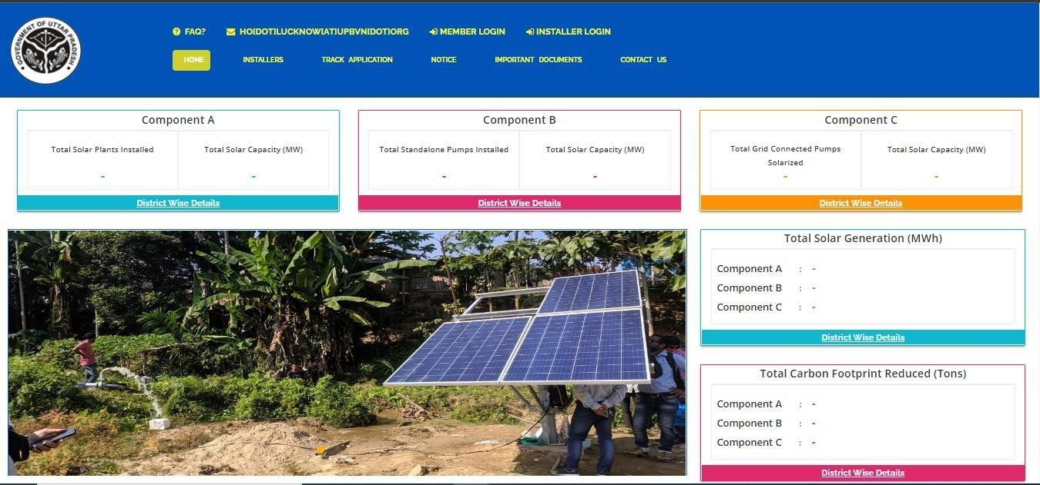

Figure 1 WELCOME PAGE

- On the welcome page’s heading, there is a provision of “Frequently Asked Questions (FAQs)” provided (as highlighted in red in above Figure 1). Below are the frequently asked questions, as shown in Figure 2.

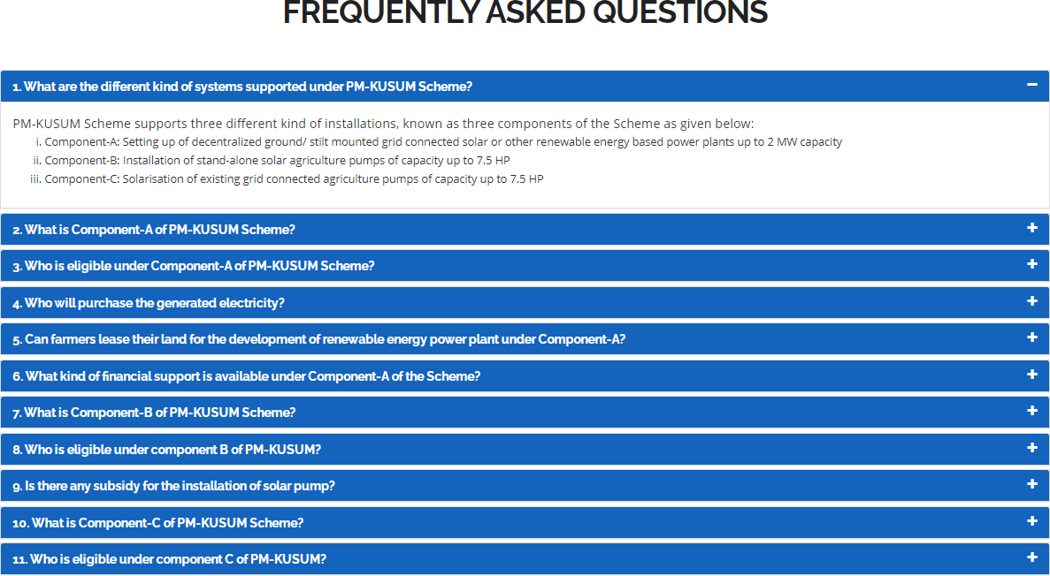
Figure 2 FAQ

- The provision of language is selection is also there on the “Welcome Page” in which default selection will be of “English” language (highlighted in yellow in Figure 1). After selection of different language, corresponding output are shown below in Figure 3.

  - Selected – Hindi

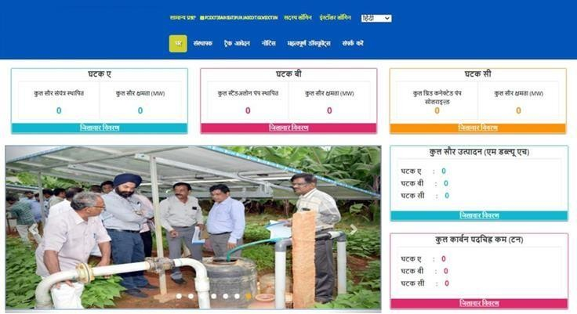


Figure 3 HINDI SELECTED

- On the welcome page, there are 5 indicators among which 3 depicting the components of PM-KUSUM scheme along with the cumulative figures of total solar plants and pumps installed and their capacity and other two depicts Total Solar Generation (MWh) and Total Carbon Footprint Reduced (Tons) (as shown in Figure 1).
- To get a detailed view of the capacity installed under each component, click on the ‘District Wise Details’ tab under each component (as shown in below Figure 4 C Feeder Level Solarisation (C FLS) District Wise Details the blue box), which will generate a detailed report in tabular form.(refer Figure 5)

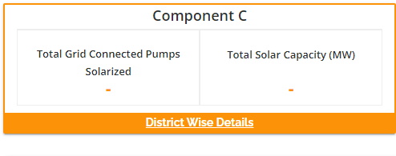
Figure 4 C FEEDER LEVEL SOLARISATION (C FLS) DISTRICT WISE DETAILS

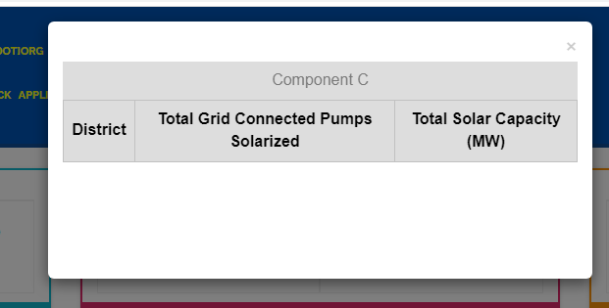

Figure 5 PM-KUSUM C FEEDER LEVEL SOLARISATION (C FLS) DISTRICT WISE STATUS REPORT

- District Wise Details provide the view of total installed Standalone Pumps and its capacity against Districts of State.
- Such report can be also seen without login into the SEDM Portal.

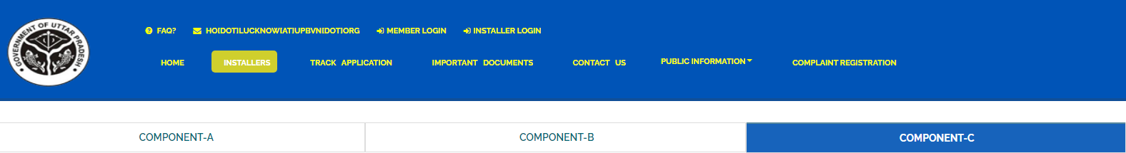
Figure 6 INSTALLERS

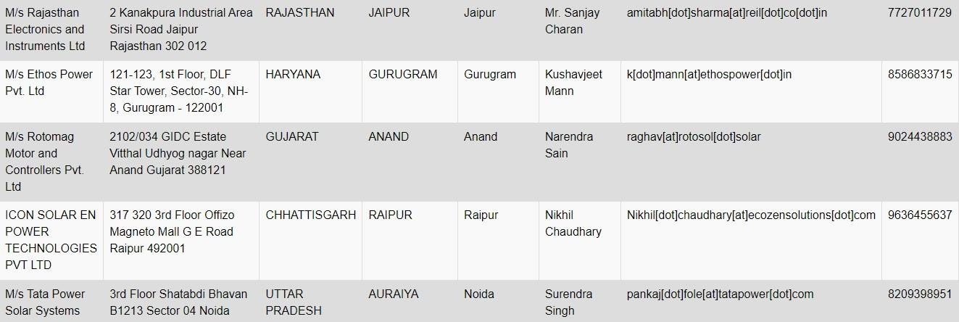

  - “TRACK APPLICATION” tab provides the facility of tracking the Farmer Application by entering Application number or Consumer/Farmer Mobile No (as shown in Figure 7 in red box)

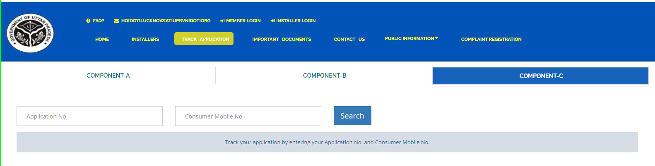
Figure 7 TRACK APPLICATION

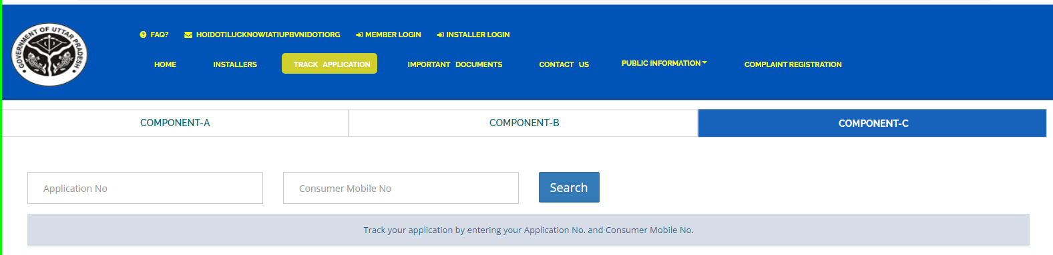
Figure 8 APPLICATION ENTERED TO TRACK APPLICATION

  - When user enter Application no. or Consumer/Farmer Mobile no. and click on “Search” button, below report (Figure 9) will be shown.
  - The completed status will have date on which status was completed.

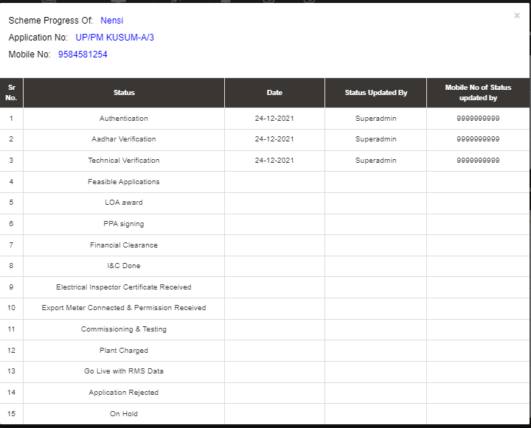
Figure 9 TRACK APPLICATION REPORT

- “IMPORTANT DOCUMENTS” tab displays list of documents that are vital for the PM KUSUM scheme. (as shown in Figure 10)
  - Uploaded Documents can be taken out manually.

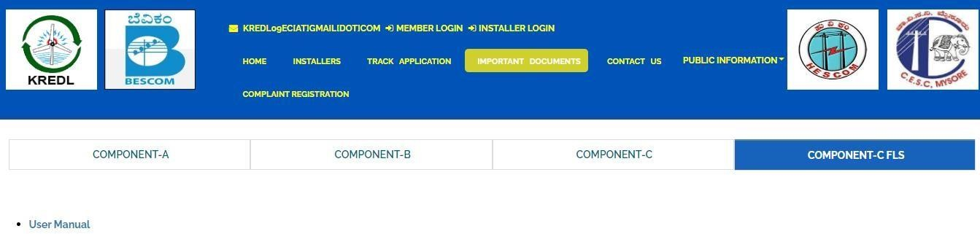
Figure 10 IMPORTANT DOCUMENTS

- “CONTACT US” tab displays list of all Nodal officers of Districts for PM KUSUM C Feeder Level Solarisation (C FLS). (as shown in Figure 11)

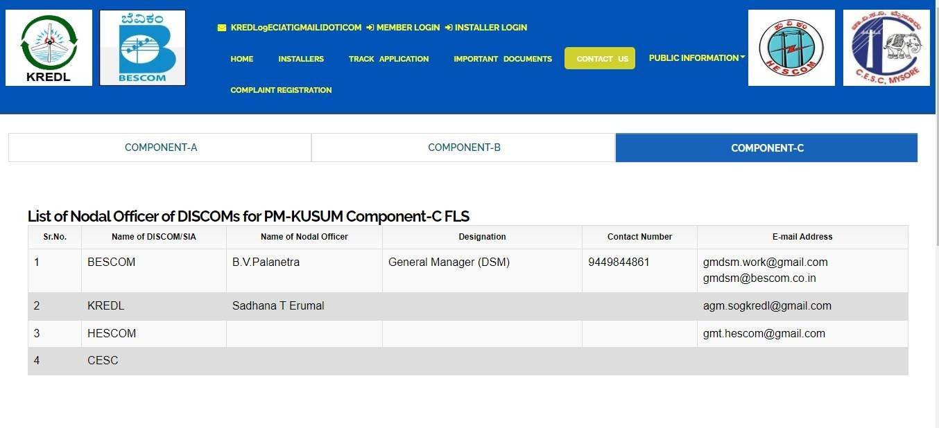
Figure 11 CONTACT US

SIGN IN ON SEDM PLATFORM
  - To log in onto the SEDM portal, users can click on the “MEMBER LOGIN OR INSTALLER LOGIN” option on the Welcome Page.(highlighted in red in Figure 12)

Table 4 INFORMATION OF LOGIN
Role | Login Option
Head Officer
District Officer | MEMBER LOGIN
Empanelled Agency/Developer | INSTALLER LOGIN

- Such login options will be visible to all users including HO, DISCOM, SDN and EA.

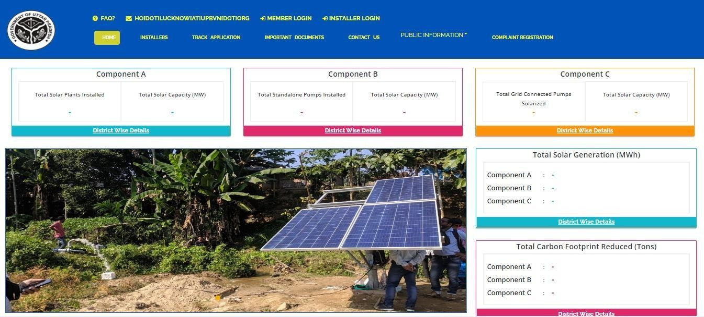
Figure 12 SIGN IN PAGE
- By clicking on the login options, it will show a pop-up box where the user must enter his username, password and the captcha code to sign in into their account.
- The user will be provided the credentials via email if the email gateway is configured.
- NOTE: If email gateway is not configured then Organization admin can share credentials manually. (click User Role for more details)

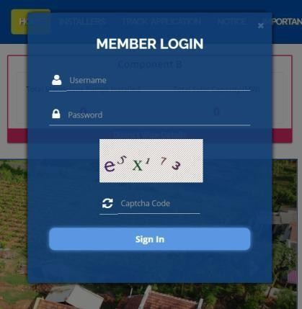  Member Login pop-up for State Implementing Agency | 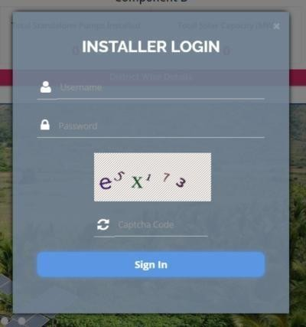  Installer Login pop-up for Empanelled Agency

Figure 13 SIGN IN SCREENS

HOME PAGE

  - After the user successfully logs in to the SEDM portal it lands on the Home Page screen.
On the Home Page, users can select any of the 1 components to view the required Consumer/Farmer details, asset management, application tracking, performance analysis, etc.
  - Component A: Distributed Solar PV
  - Component B: Off Grid Solar Pump
  - Component C: Grid Connected Solar Pump

- Navigation Steps: -
- Sign in on the State SEDM Portal
- Click on ‘Off Grid Solar Pump’ icon on the Home Page as shown in the Figure 14 to access the Component-B of PM- KUSUM Scheme.

  - Users having rights to access of related components (A, B, C) only will be allowed to navigate through.

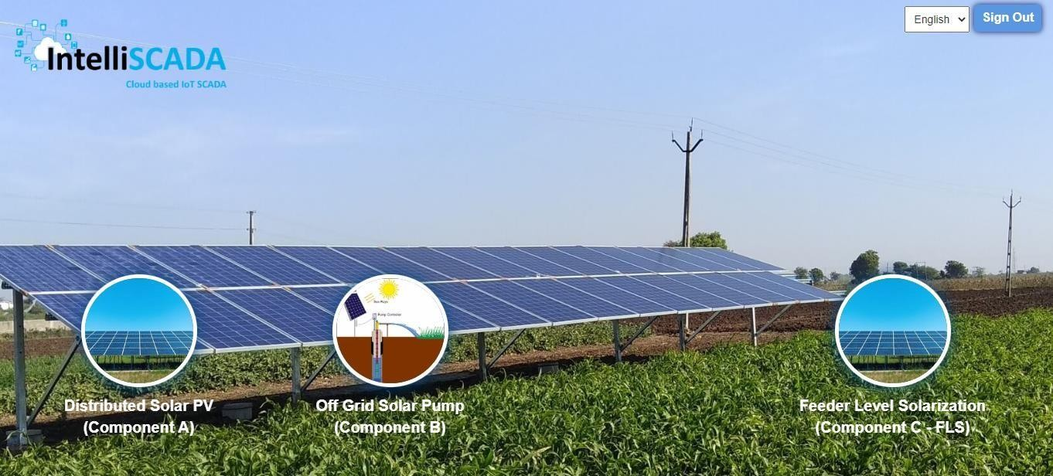

Figure 14 HOME PAGE

USER PROFILE PAGE

  - The users can view their profile information by clicking on the ‘user’ icon image in the top right corner (highlighted in red in below Figure 15) on this manual is for Component B le bar and then selecting the ‘My Profile’ option.
    - Navigation Steps: -
- Sign in on the State SEDM Portal
- Click on the ‘User’ icon on the Title Bar of the SEDM Portal Dashboard

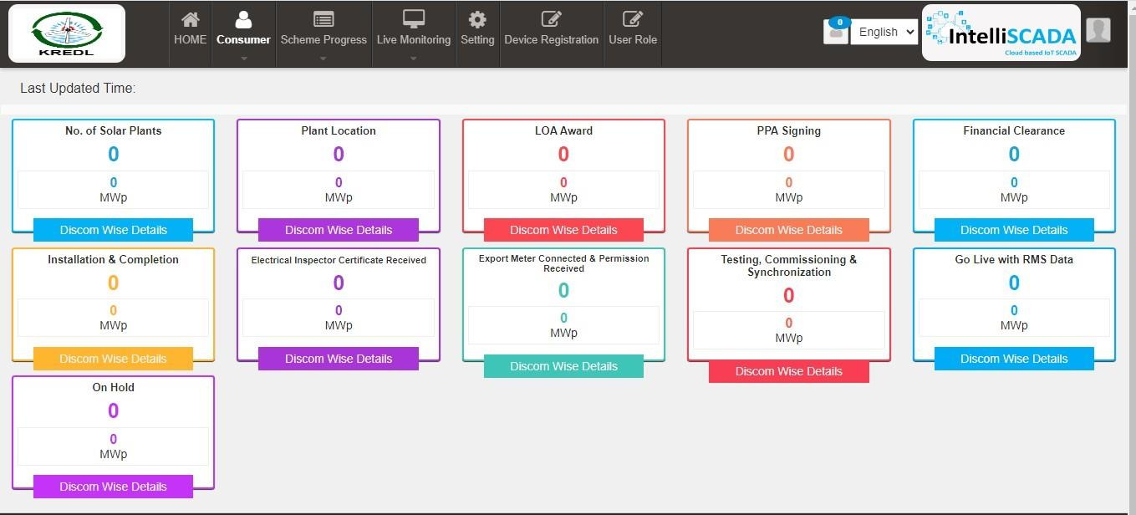
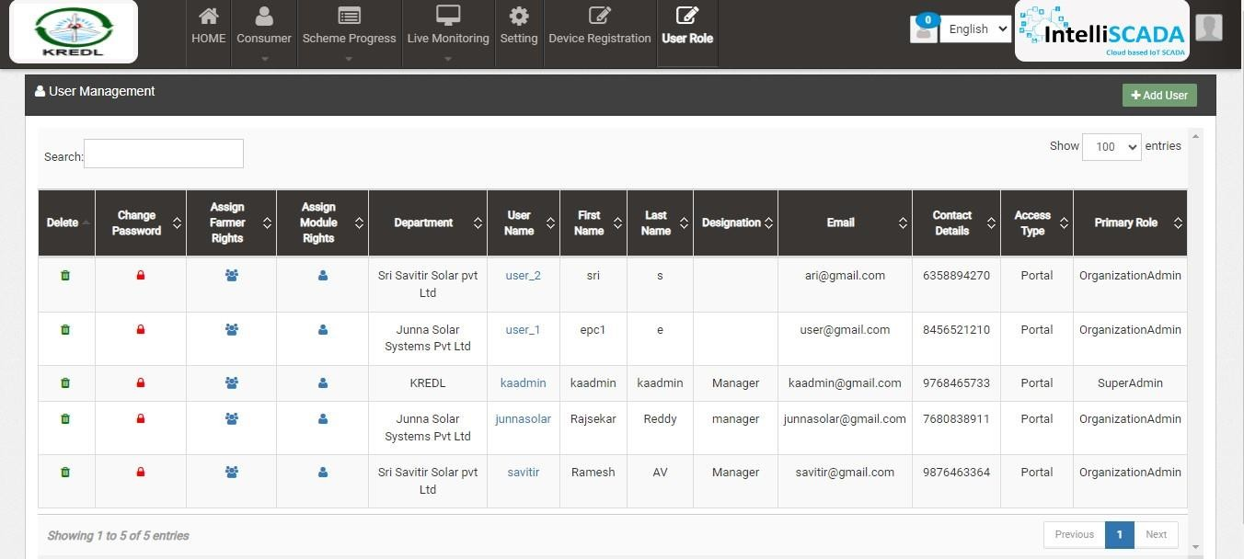

Figure 15 USER ROLE

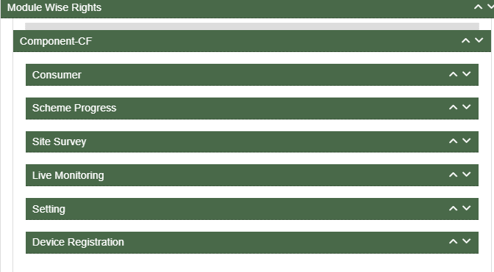

Figure 16 USER PROFILE INFORMATION BOX

  - The following details are listed under ‘My Profile’ template card:
- Username
- First Name
- Last Name
- Email
- Phone Number
- Department
- Department Role
- Access Type
- User Rights

  - If the user wishes to change any details or sees a discrepancy in his details, he can contact the SEDM support team for required modifications.

  - Ctrl + Click here “Support Team” for Support Team Contact detail

CHANGE PASSWORD

  - The users can change their account password by clicking on the ‘user’ icon image in the top right corner on the title bar and then selecting the ‘Change Password’ option.
    - Navigation Steps: -
- Sign in on the State SEDM Portal
- Click on the ‘User’ icon on the Title Bar of the SEDM Portal Dashboard
- Click on the ‘Change Password’ option from the drop-down menu

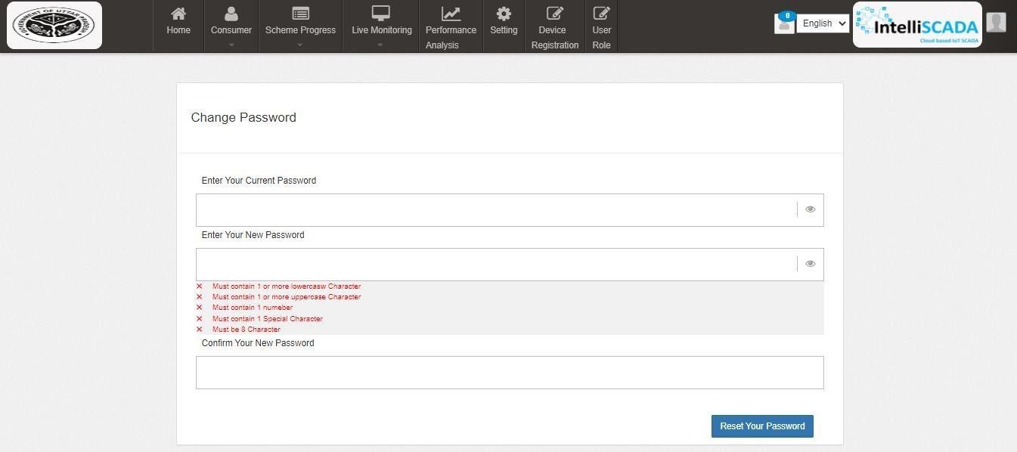
Figure 17 CHANGE PASSWORD

  - The users can change their password by entering the current password, a new password and re-entering the new password to confirm it in the mentioned text fields. Then click on the ‘Change Password’ button to complete the process.

  - Your New Password box and Confirm Your New Password box must have same password inputs otherwise an error will occur i.e. Please enter the same password as entered New Password

Note: Users should make sure their passwords are strong and secure as per below mentioned validations to avoid any untoward activities or misuse of their credentials by any other party.
- Length must be of minimum 8 characters
- 1 or more lowercase character
- 1 or more uppercase character
- 1 special character
- 1 or more numbers
-

REGISTER NEW STATE IMPLEMENTING AGENCY (SIA)

- SIA will be shared Super Admin credential that can have access to all the three Components i.e. Distributed Solar PV (Component A), Off Grid Solar Pump (Component B) and Grid Connected Solar Pump (Component C) and also can have access to all the below mentioned 9 modules of portal:
  - Consumer
  - Scheme Progress
  - Asset
  - Live Monitoring
  - Performance Analysis
  - Setting
  - Device Registration
  - User Role
  - Complaint

Figure 18 MODULES

  - Super Admin can register new State Implementing Agency (SIA) and Empanelled Agency (EA) in “Setting” module.

SETTING MODULE

  - New Empanelled Agency & State Implementing Agency can be registered in “Setting” module.

- Navigation Step :-
- Sign in on the State SEDM Portal
- Click on the Setting Module

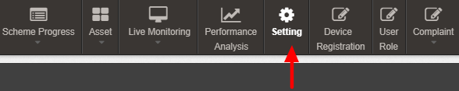
Figure 19 SETTING MODULE

REGISTRATION OF DISCOM

    - Super Admin can register DISCOM by clicking on “DISCOM” tab as pointed in below Figure 19.

- Navigation Step :-
- Sign in on the State SEDM Portal
- Click on the Setting Module
- Click on DISCOM

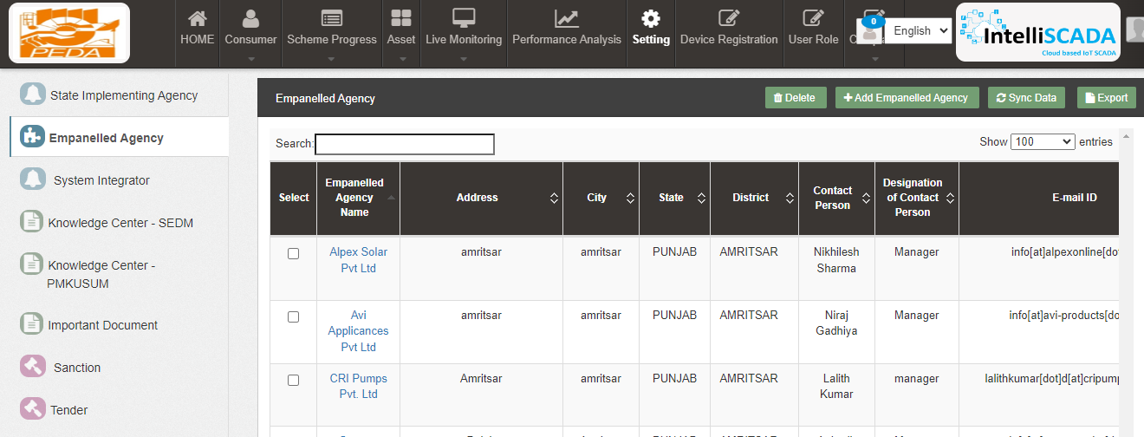

Figure 20 EMPANELLED AGENCY TAB

Figure 21 EMPANELLED AGENCY TAB DASHBOARD

Table 5 EMPANELLED AGENCY DASHBOARD DESCRIPTION
Action | Functionality | Highlighted Colour | Type | Description
Search | Empanelled Agency | Blue | Text Box | Enter input to explore agencies details
Delete | Delete Empanelled Agency | Yellow | Button | Select check box (highlighted in pink) and click on delete button to Delete Empanelled Agency. This will be a soft delete wherein, all the data related to DISCOM will still be stored  in Database
Add DISCOM | Register Empanelled  Agency | Red | Button | Register new Empanelled Agency by clicking  on Add Empanelled Agency button

Export | CSV file for Empanelled  Agency details | Green | Button | Download CSV file of DISCOM details

    - User can register new Empanelled Agency by clicking on “Add Empanelled Agency button” button. (highlighted in red in Figure 20)
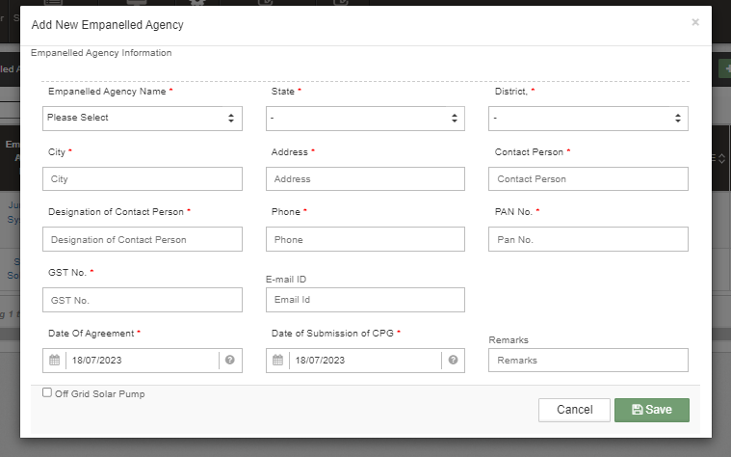
Figure 22 NEW EMPANELLED AGENCY DETAILS

Table 6 DISCOM REGISTRATION FIELDS DESCRIPTION
Field | Input | Mandatory Field | Sample Values | Descriptio n | Validations
Discom Code | Text box | ✓ | 01562 | Enter Discom code (if available) | -
Discom Name | Dropdown | ✓ | BESCOM | Enter name of the DISCOM | -
State Code | Text box | ✓ | 29 | Enter state code as per the LG Directory | -

    - After filling all the details, user has to click on the “Save” button (highlighted in red in Figure 21) to register discom.

REGISTRATION OF STATE IMPLEMENTING AGENCY (SIA)

- Registering Taluka

    - Super Admin can register New State Implementing Agency by clicking on “State Implementing Agency” tab as pointed in below Figure 22.

- Navigation Step :-
- Sign in on the State SEDM Portal
- Click on the Setting Module
- Click on State Implementing Agency

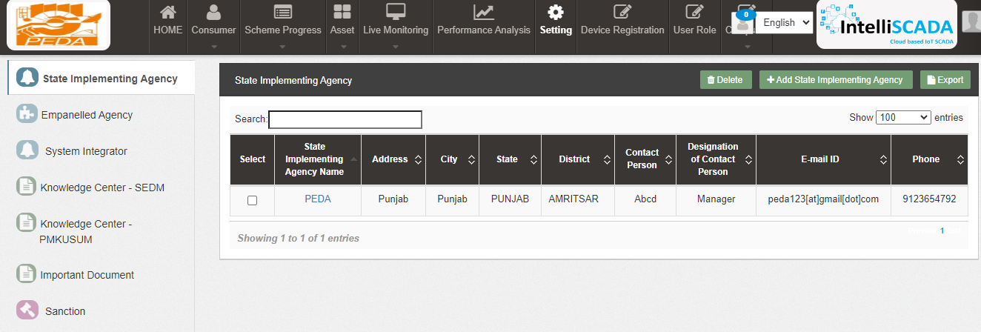
Figure 23 STATE IMPLEMENTING AGENCY TAB

Figure 24 STATE IMPLEMENTING AGENCY TAB DASHBOARD

Table 7 STATE IMPLEMENTING AGENCY DASHBOARD DESCRIPTION
Action | Functionality | Highlighted Colour | Type | Description
Search | Search Taluka | Blue | Text Box | Enter input to explore State Implementing Agency details
Delete | Delete Taluka | Yellow | Button | Select check box (highlighted in pink) and click on delete button to Delete Taluka . This will be a soft delete wherein, all the data related to Taluka will still be stored in Database
Add Taluka | Register new Taluka | Red | Button | Register new Taluka by clicking on Add Taluka button
Export | CSV file for Taluka | Green | Button | Download CSV file of State Implementing Agency details,

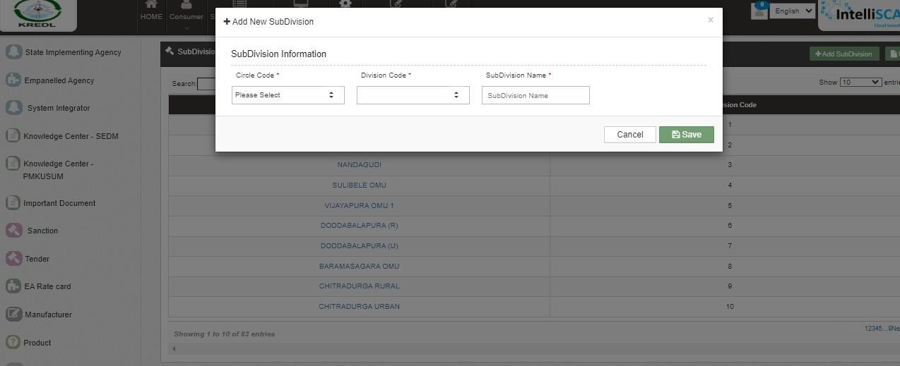
Figure 25 NEW SUB DIVISION DETAILS

Table 8 STATE IMPLEMENTING AGENCY REGISTRATION FIELDS DESCRIPTION
Field | Input | Drop Down Options | Mandatory Field | Sample Values | Description | Validations
Circle Code | Drop Down | - 015234 | ✓ | 015234 | Select Circle code as per | -

 |  |  |  |  | the requirement.
Division Code | Drop Down | - | ✓ | xyz | Select division code  as per the requirement. | -
Subdivision name | Text | - | ✓ | 014754 | Enter name | -

    - After filling all the details, user has to click on the “Save” button (highlighted in red in Figure 24) to register New taluka
    - After registering circle code and Division Code , Subdivision name can now create new subdivision

USER ROLE MANAGEMENT

User Role Management

- User Role Management module facilitates the creation of users of SIA with assignment of roles.
- Furthermore, it also provides the functionality to the Organization Admin of registering the new users of the corresponding Organization with access rights.
  - After registering the Discom/SIA and Taluka, Super Admin can now register new users and assign roles through User Role module.

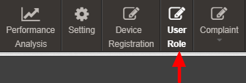
Figure 26 USER ROLE MODULE

REGISTER NEW USER

Register New User

- To register new user, Super Admin has to click on the “Add User” button (pointed in below Figure 26).

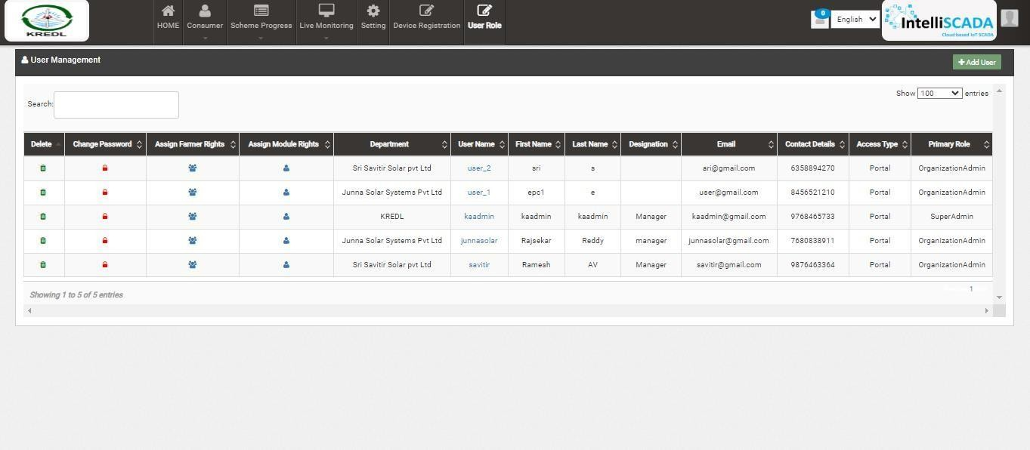

Figure 27 ADD USER BUTTON ON USER ROLE DASHBOARD

- To register new user, user has to enter two types of following details :
  - User Information
  - Module Roles
Add User

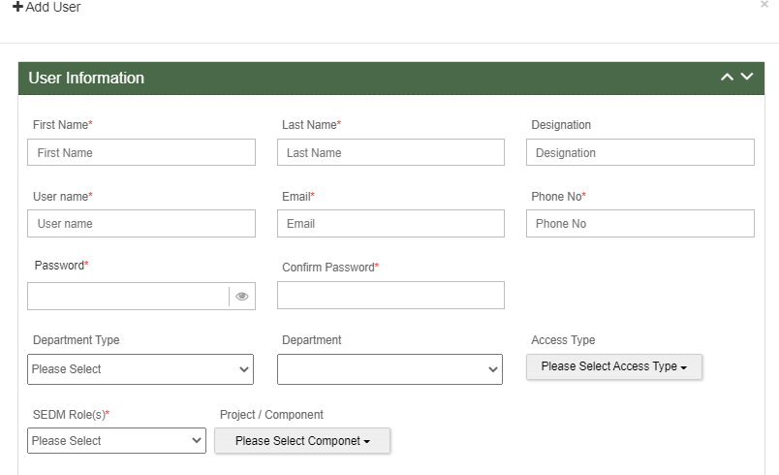
Figure 28 ADD USER FORM

    - User Information

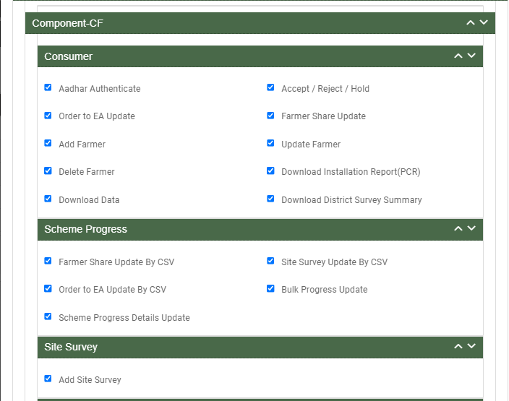

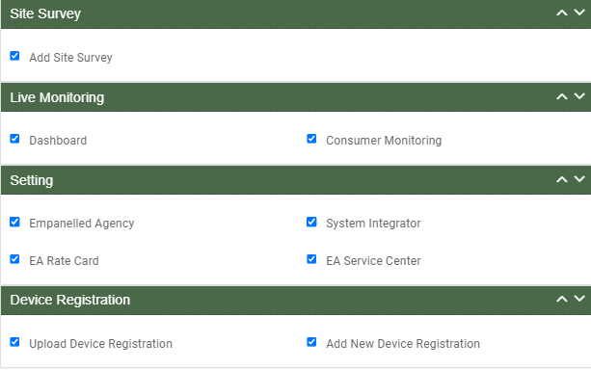

Figure 29 USER RIGHTS

Table 9 NEW USER REGISTRATION FIELDS DESCRIPTION
Field | Input | Drop Down & Check Box  Options | Mandatory Field | Sample Values | Description | Validations
First Name | Text | - | ✓ | Ram | Input first name of the user | -
Last Name | Text | - | ✓ | Sharma | - | -
Designation | Text | - | - | EPC | - | -
Username | Text | - | ✓ | ramsharma | - | -
Email | Email | - | ✓ | ram@gmail.com | - | It must contain :  - Alphabets (a-z) in lower case only  - Digits (0-9) (non mandatory)

- Printable characters ( ! # $ % & ’ * + - / = ? ^ _ ` { } | ~ )
- Symbol “@”
- Domain name (gmail , gov ,
yahoo)
- A period (.)
- Sub domain name (co.in ,
com , org)
Phone No | Numerical | - | ✓ | 7458748588 | - | - Must be of 10 digits only
Password | Password | - | ✓ | Ram@123 | - | - Length must be of minimum 8 characters  - 1 or more lowercase character  - 1 or more uppercase character  - 1 special character  - 1 or more numbers
Confirm Password | Password | - | ✓ | Ram@123 | - | - Length must be of minimum 8 characters  - 1 or more lowercase character  - 1 or more uppercase character  - 1 special character  - 1 or more numbers
Department Type | Drop Down | - State Implementing Agency  - Empanelled Agency  - System Integrator | ✓ | Empanelled Agency | Selection of relevant Department as per the requirement.  System Integrator is a separate Empanelled agency who installs RMS system separately as  required in GJ
Department | Drop Down | - KREDL | ✓ | Gautam Solar Pvt. Ltd. | Selection of relevant department according to the  selected department type. | -
Access Type | Drop Down | - Only Configuration  - Only Portal | ✓ | Only Portal | Selection of relevant access type as per the | -

 |  | - Only Mobile Application |  |  | requirement. (refer  Table 9 ACCESS TYPE DROP  DOWN)
User Role(s) | Drop Down | - Super Admin  - Organization Admin  - User | ✓ | Super Admin | Selection of relevant user role as per the requirement. Only Super Admin can create new Super Admin user. | -
LOne (DISCOM) | Drop Down | - | ✓ | BESCOM | Selection of DISCOM | -
LTwo (circle) | Drop Down | - KOLAR  - RAMNAGAR  - TUMKUR  - DAVANAGER E | ✓ | - TUMKUR | Selection of circle  . | -
LThree (Division) | Drop Down | - HOSAKOTE  - NELAMANGA LA | ✓ | - HOSAKO TE  ✓ | SELECTION OF DIVISION
LFour (Subdivisio n) | Drop Down | - DEVANHALLI  - HOSAKOTE  - NANDAGUDI  - SULIBELE OMU | ✓ | DEVANHALLI  ✓ | SELECTION OF SUBDIVISION
LFive (Substation) | Drop Down | - Substation  - DEVANHALLI  _66  - KUNDANA_6 6 | ✓ | - Substatio n | SELECTION OF SUBSTATION
Project / Component | Drop Down | - Distributed Solar PV – A  - Off Grid Solar Pump – B  - Feeder Level Solarization (comp c – FLS) | ✓ | Grid Connected Solar Pump –C | Selection of PM- KUSUM Scheme Component | -

Department Type Drop Down | Department Type | Description | Department Drop Down | Description
- State Implementing Agency  - Empanelled Agency  - System Integrator | State Implementing Agency | Selecting this option indicates that the new user will belong from the State  Implementing Agency department type. | - PEDA | By selecting SIA will provide SIA list to process further as  shown in Department Drop Down.
 | Empanelled Agency | Selecting this option indicates that the new user will belong from the  Empanelled Agency department type. | - Sai Savitr Solar Pvt. Ltd.  - Junna Solar System Pvt. Ltd. | By selecting EA will provide EA list to process further as  shown in Department Drop Down.
 | System Integrator | Selecting this option indicates that new user will belong from the System Integrator department type. | - HKRP  - ABCD | By selecting System Integrator will provide System Organization list to process further as shown in Department Drop Down.

Table 9 ACCESS TYPE DROP DOWN

Access Type Drop Down | Option Name | Description
- Only Configuration  - Only Portal  - Only Mobile Application | Only Configuration | This option gives writes to user to access configuration.
 | Only Portal | This option gives writes to user to access Portal.
 | Only Mobile Application | This option gives writes to  user to access Mobile Application

Table 10 USER ROLE DROPDOWN
User Role Drop Down | Role | Access | User Creation | Specifications
- Super Admin  - Organization Admin  - User | Super Admin | This user has access of every module of State SEDM Platform. | This user can create “Organization Admin” & “User” and also can provide access to any of all modules. | This user can only register Tender, State Implementing Agency  (SIA) and Empanelled Agency (EA).
This user can create
other Super Admin of SIA only and not of EA.
- Super Admin  - Organization Admin  - User | Organization Admin | This user has access to the modules that Super Admin provided. | This user can create other “Organization Admin” and “User” and can provide access to  those modules only that he have access of. | This user can create one or more “User” for its own Organization only.
- Super Admin  - Organization Admin  - User | User | This user has access to the modules that Super Admin or  Organization Admin provided. | This user can neither create any user nor can provide any access. | This user cannot register State Implementing Agency (SIA) & Empanelled Agency (EA)  and cannot create any “User”.

Module Roles

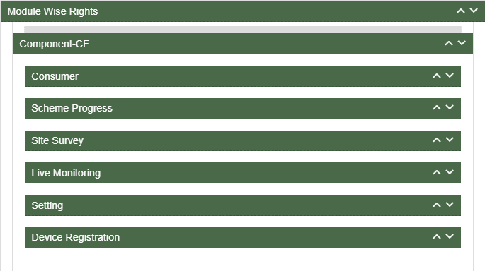
Figure 30 MODULE ROLES

- User has to click anywhere in the red highlighted boxes (as shown in the above Figure 28) to open up the module to provide the access of Functionality to the existing user.
- After opening the module, user has to select the Check Box (highlighted in red in below Figure 29) to choose the access of Functionality for the new user.
- Following are the Functionality, whose access can be decided by the Super Admin / Organization Admin for the new users or existing users :

Consumer Functionality

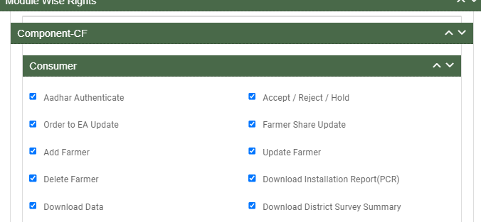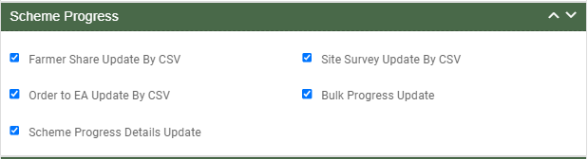
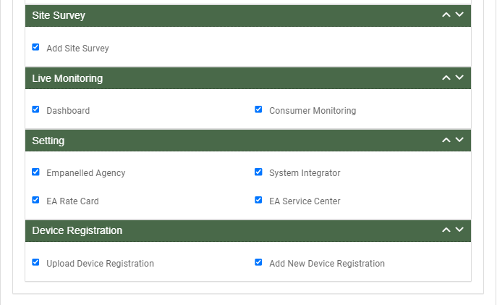
Figure 31 CONSUMER FUNCTIONALITY

Table 11CONSUMER FUNCTIONALITY
Consumer Functionality Name | Description
No of Solar Plants | It gives information about how many solar plants are planted
Plant Location | This gives us information about location of plant
LOA award | Selecting this Functionality will provide the access to update issue of LOA to the beneficiary/developer.
PPA signing | Selecting this Functionality will provide the access to update the PPA agreement between the developer and the DISCOM/SIA
Financial Clearance | Selecting this Functionality will provide the access to update the  Financial Clearance between beneficiary/developer and DISCOM/SIA
Installation & Completion | This entry demonstrates that at which date solar plant is established
Electrical Inspector and Certificate received | This entry demonstrates that inspection is done and district officer gets certificate
Export meter connected & Permission received | Meter is connected with plant and permission received .
Testing, Comissio  ning, & synchronization | This functionality provides updates about testing, commissioning and synced data
Plant Charged | Plant is charged
Go live with RMS Data | District officer can get information of live data
On Hold | This step demonstrates that application is on hold

Scheme Progress

Figure 32 SCHEME PROGRESS FUNCTIONALITY

Site Survey Functionality

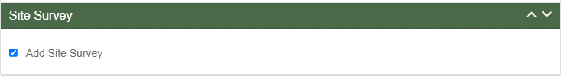
Figure 33
Figure 34 SITE SURVEY FUNCTIONALITY

TABLE 12 SITE SURVEY FUNCTIONALITY

Site Survey Functionality Name | Description

Add Site Survey | Selecting this Functionality will provide the access to Site Survey Mobile Application update the consumer/farmer application status “Site Survey” via Site Survey.

FIGURE 32 ASSET FUNCTIONALITY

Live Monitoring Functionality

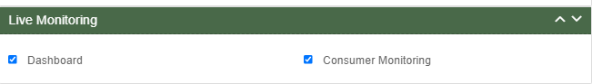
Figure 35 LIVE MONITORING FUNCTIONALITY

TABLE 13 LIVE MONITORING FUNCTIONALITY

Live Monitoring Functionality Name | Description
Dashboard | Selecting this Functionality will provide the access Live Monitoring Dashboard
Consumer Monitoring | Selecting this Functionality will provide the access of consumer monitoring in which user can monitor RMS data, map individual Asset Serial no. and IMEI nos., update I&C Done status and I&C Verification and Insurance

Device registration Functionality

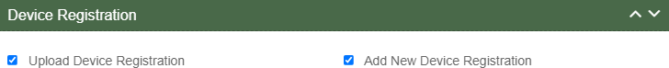

Figure 36 DEVICE REGISTRATION FUNCTIONALITY

TABLE 14 DEVICE REGISTRATION FUNCTIONALITY

Device Registration Functionality Name | Description
Upload Device Registration | Selecting this Functionality will provide the access to register Device IMEI numbers in bulk by uploading a CSV file.
Add New Device Registration | Selecting this Functionality will provide the access to register a Device IMEI number.

- After selection of the Functionality, Super Admin can create new user role and can also provide access to modules and Functionality to the new user. (Refer “User Role” drop down in New User Registration form - Error! Reference source not found.)

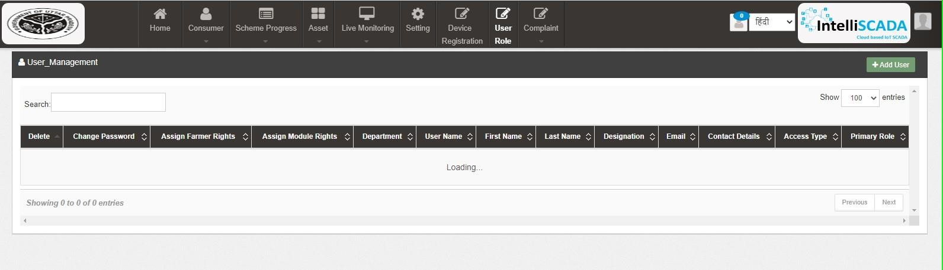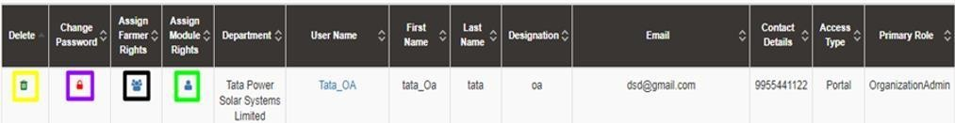

Figure 37 USER ROLE DASHBOARD

Table 12 USER ROLE DASHBOARD DESCRIPTION
Action | Functionality | Highlighted Colour | Type | Description
Search | Search User | Blue | Text Box | Enter input to explore User details
Add User | Create New User | Red | Button | Create New User by clicking on Add User button
Delete Icon | Delete User | Yellow | Icon Button | Click on delete green icon button to Delete User details
Change Password Icon | Change Password | Purple | Icon Button | Click Change password red icon to change password
Assign Farmer Rights | Farmer wise Access | Black | Icon Button | This functionality will provide access to the user to view the data of RMS system of allowed/mapped farmers
Assign Module Rights | Edit Module Rights | Green | Icon Button | Using this option organization admin can modify User Rights.

Change Password

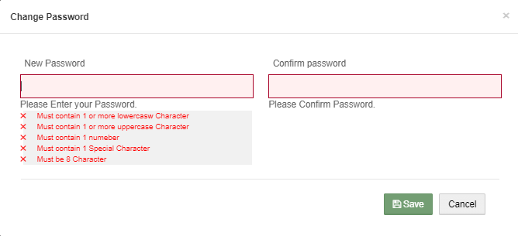
Figure 38 CHANGE PASSWORD SCREEN

- User has to enter “New password” and “Confirm password” as shown in above Figure 36.

Assign Farmer Rights

- By clicking on the icon of “Assign Farmer Rights” (highlighted in black in Figure 35), Super Admin / Organization admin can provide access to the user to view the data of RMS System mapped with the selected farmers. (window screen for the same shown below in Figure 37)

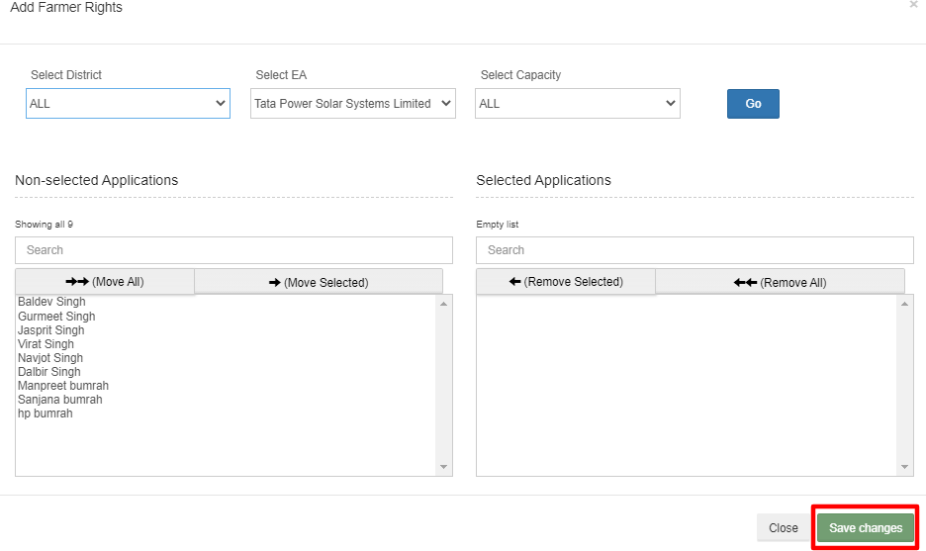
Figure 39 ASSIGN FARMER RIGHTS

- By moving beneficiary from Non-Selected Applications to Selected Applications, that particular user will get the access to view the RMS data of the selected Applications.
- User can update the module and Functionality access of any particular existing user by clicking on the user icon. (highlighted in green in Figure 35)

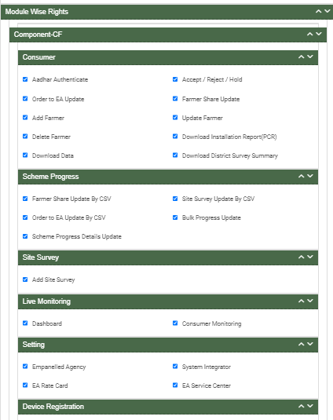
- After clicking on user icon, a Screen will occur for the editing the access of the Functionality. (as shown in

Figure 40 USER ROLE MODULE SELECTION SCREEN

MASTER SETTINGS (CONFIGURATIONS)

- SIA with Super Admin credentials can add or update several following settings :
  - Empanelled Agency
  - System Integrator
  - EA rate card
  - EA Service center
- These updates can be performed in the “Setting” module.

- Navigation Step :-
- Sign in on the State SEDM Portal
- Click on the Setting Module

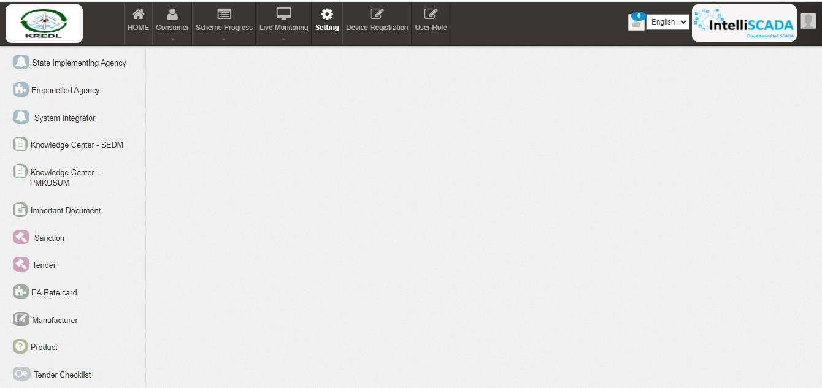
Figure 41 DASHBOARD OF SETTINGS

EA RATE CARD

    - EA Rate Card includes Central/State/Farmer Contribution as the subsidy to the Farmer’s total cost of the Solar Pump.
    - It gives information of the total cost of the Solar Pump in “Rs.” and in “%” divided between Central Government, State Government and the Consumer/Farmer.
    - Super Admin can update these information in the “Setting” module.

- Navigation Step :-
- Sign in on the State SEDM Portal
- Click on the Setting Module
- Click on EA Rate Card Tab
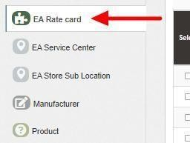
Figure 42 EA RATE CARD TAB

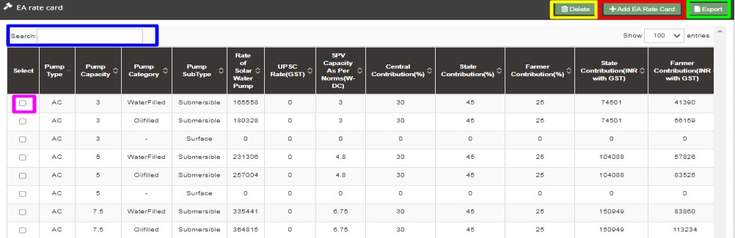

Figure 43 EA RATE CARD DASHBOARD

Table 13 EA RATE CARD DASHBOARD EXPLANATION
Action | Functionality | Highlighted Colour | Type | Description
Search | Search EA Rate Card | Blue | Text Box | Enter input to explore EA Rate Card details
Delete | Delete EA Rate Card | Yellow | Button | Select check box (highlighted in pink) and click on delete button to Delete EA Rate Card details

Add EA Rate Card | Add new EA Rate Card | Red | Button | Register new EA Rate Card by clicking on Add EA Rate Card Sub Location button
Export | CSV file for EA Rate Card details | Green | Button | Download CSV file of EA Rate Card details

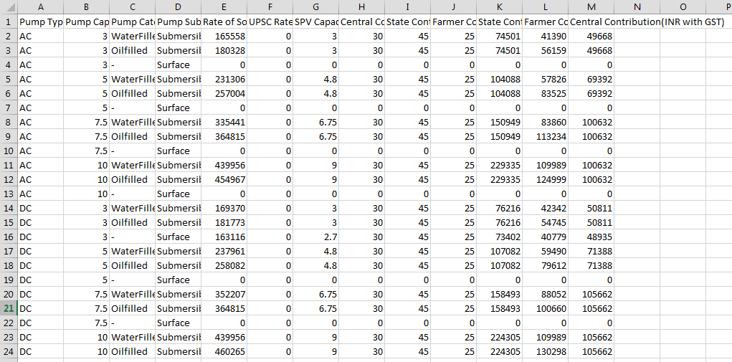
Figure 44 CSV OF EA RATE CARD DETAILS FIGURE

    - User can add new EA Rate Card by clicking on “Add EA Rate Card” button. (highlighted in red in Figure 40)

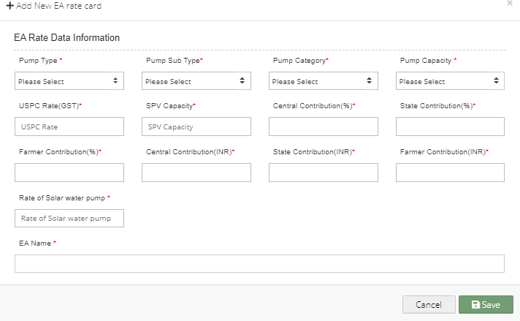

Figure 45 NEW EA RATE CARD DETAILS

Table 17 EA RATE CARD REGISTRATION FIELDS DESCRIPTION

Field | Input | Drop Down & Check Box Options | Mandat  ory Field | Sample Values | Description
Pump Type | Text | - AC  - DC | ✓ | AC | Selection of the Pump Type
Pump Sub Type | Drop Down | - Submersible  - Surface | ✓ | Submersible | Selection of the Pump Sub  Type
Pump Category | Drop Down | - Oil Filled  - Water Filled | ✓ | Water Filled | Selection of the Pump  Category
Pump Capacity | Drop Down | - 1 HP  - 2 HP  - 3 HP  - 5 HP  - 7.5 HP  - 10 HP | ✓ | 5 HP | Selection of the Pump Capacity
USPC Rate (GST) | Numerical | - | ✓ | 0 | -
SPV Capacity | Numerical | - | ✓ | 3 | -
Central  Contribution (%) | Numerical | - | ✓ | 30 | -
State  Contribution (%) | Numerical | - | ✓ | 45 | -
Farmer  Contribution (%) | Numerical | - | ✓ | 25 | -
Central Contribution  (INR) | Numerical | - | ✓ | 49668 | -

State Contribution  (INR) | Numerical | - | ✓ | 74501 | -
Farmer Contribution  (INR) | Numerical | - | ✓ | 41930 | -
Rate of Solar  Water Pump | Numerical | - | ✓ | 16558 | -
EA Name | Drop Down | - Sai Babuji Project Pvt. Ltd.  - Gautam Solar Pvt. Ltd.  - CRI Pumps Pvt. Ltd.  - Shakti Pumps Ltd.  - Solex Energy Ltd.  - Junna Solar System Pvt. Ltd. | ✓ | Sai Babuji Project Pvt. Ltd | Selection of the relevant Empanelled Agency

    - After filling all the details, user has to click on the “Save” button (highlighted in red in above Figure 42) to register New EA Rate Card.

REGISTRATION OF EA STORE SUB LOCATION

    - EA Store Sub Location is the location of the Empanelled Agency where the assets are inspected and stored.
    - Super Admin can register EA Store Sub Location Details by clicking on “EA Store Sub Location” tab as pointed in below Figure 43.
    - SIA with Super Admin credentials needs to be collect the store location details from Empanelled agencies and then register the store sub-location details here.

- Navigation Step :-
- Sign in on the State SEDM Portal
- Click on the Setting Module
- Click on EA Store Sub Location Tab

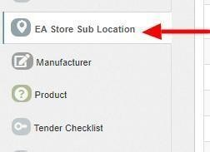

Figure 46 EA STORE SUB LOCATION TAB

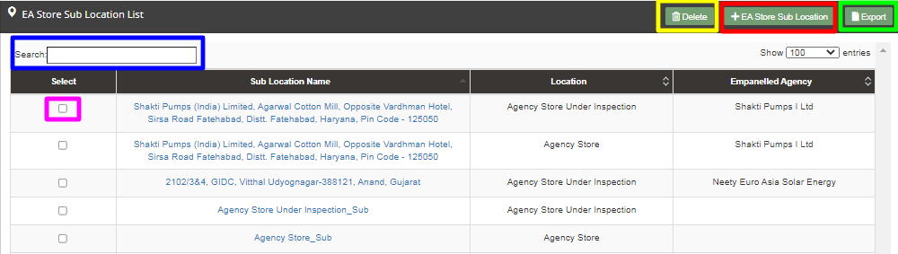

Figure 47 EA STORE SUB LOCATION DASHBOARD

Table 14 EA STORE SUB LOCATION DASHBOARD EXPLANATION
Action | Functionality | Highlighted Colour | Type | Description
Search | Search EA Store Sub Location | Blue | Text Box | Enter input to explore EA Store Sub Location details

Delete | Delete EA Store Sub Location | Yellow | Button | Select check box (highlighted in pink) and click on delete button to Delete EA Store Sub Location details
Add EA Store Sub Location | Register new EA Store Sub Location | Red | Button | Register new EA Store Sub Location by clicking on Add EA Store Sub Location button
Export | CSV file for EA Store Sub Location details | Green | Button | Download CSV file of EA Store Sub Location details

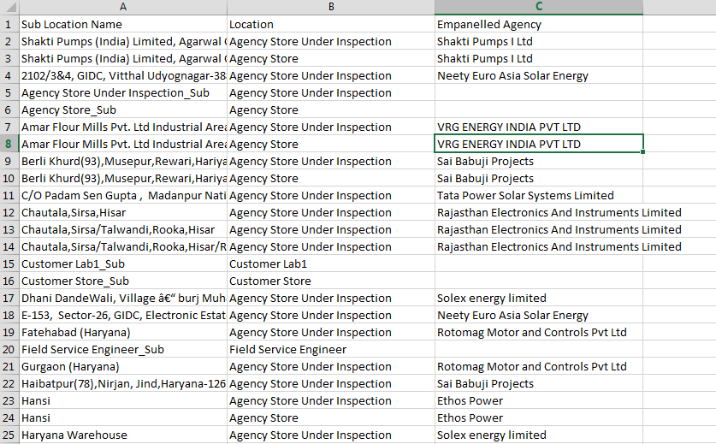
Figure 48 CSV OF EA STORE SUB LOCATION DETAILS

    - User can register new EA Store Sub Location by clicking on “Add EA Store Sub Location” button. (highlighted in red in Figure 44)

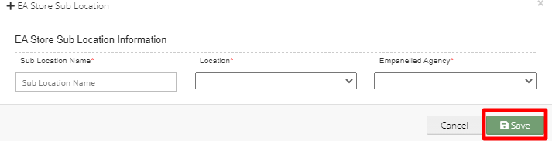
Figure 49 NEW EA STORE SUB LOCATION DETAILS

Table 15 EA STORE SUB LOCATION REGISTRATION FIELDS DESCRIPTION
Field | Input | Drop Down & Check Box Options | Mandator y Field | Sample Values | Description
Sub Location Name | Text | - | ✓ | Agency Store Sub | -
Location | Drop Down | - Field Service Engineer  - Agency Store Under Inspection  - Agency Store  - Manufacturer Store  - Manufacturer Service | ✓ | Agency Store Under Inspection | Selection of relevant Location
Empanelled Agency | Drop Down | - Sai Babuji Project Pvt. Ltd.  - Gautam Solar Pvt. Ltd.  - CRI Pumps Pvt. Ltd.  - Shakti Pumps Ltd.  - Solex Energy Ltd.  - Junna Solar System Pvt. Ltd. | ✓ | Gautam Solar Pvt.  Ltd. | Selection of relevant Empanelled Agency

    - After filling all the details, user has to click on the “Save” button (highlighted in red in above Figure 46) to register New EA Store Sub Location.

REGISTRATION OF MANUFACTURER DETAILS

    - Super Admin can register Manufacturer Details by clicking on “Manufacturer” tab as pointed in below Figure 47.
    - Manufacturer registration serves the purpose as the manufacturer of the assets i.e. Solar Pump, Solar Panel, Pump Controller, Structure, RMS, etc.
    - Manufacturer need to be added while creation of Asset Test Report along with the product details which will be further used in Lot creation. (click here to know more)

- Navigation Step :-
- Sign in on the State SEDM Portal
- Click on the Setting Module
- Click on Manufacturer Tab

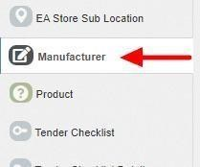
Figure 50 MANUFACTURER TAB

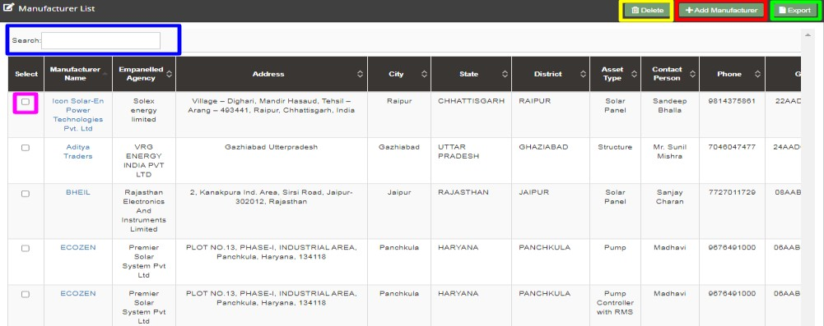

Figure 51 MANUFACTURER TAB DASHBOARD

Table 16 MANUFACTURER DASHBOARD EXPLANATION
Action | Functionality | Highlighted Colour | Type | Description
Search | Search Manufacturer | Blue | Text Box | Enter input to explore Manufacturer details
Delete | Delete Manufacturer | Yellow | Button | Select check box (highlighted in pink) and  click on delete button to Delete Manufacturer details
Add Manufacturer | Register new Manufacturer | Red | Button | Register new Manufacturer by clicking on Add Manufacturer button
Export | CSV file for Manufacturer details | Green | Button | Download CSV file of Manufacturer details

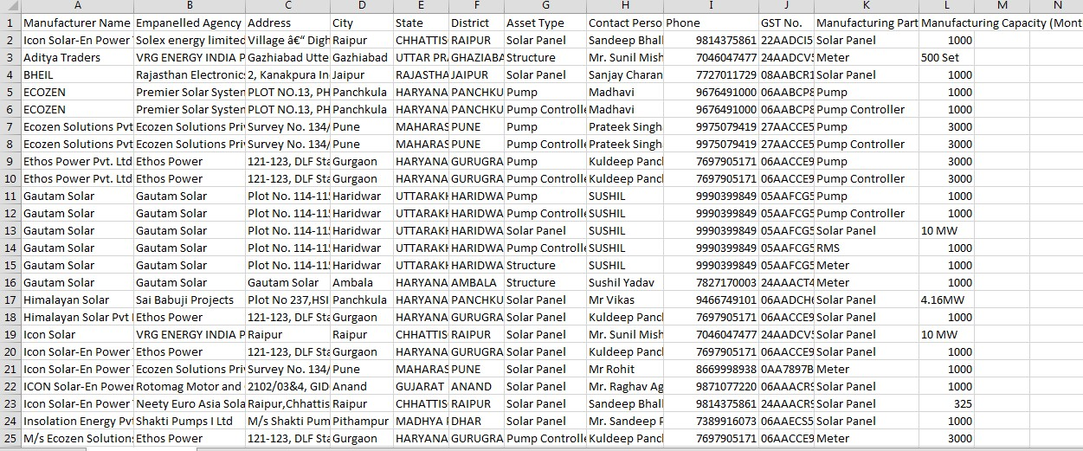

Figure 52 CSV OF MANUFACTURER DETAILS

    - User can register new Manufacturer by clicking on “Add Manufacturer” button. (highlighted in red in Figure 48)

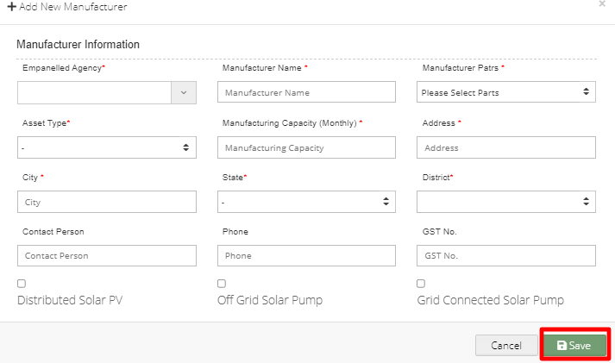
Figure 53 NEW MANUFACTURER DETAILS

Table 17 MANUFACTURER REGISTRATION FIELDS DESCRIPTION
Field | Input | Drop Down & Check Box Options | Mandatory Field | Sample Values | Description | Validations
Empanelled Agency | Drop Down | - Sri savitr Solar Pvt. Ltd.  - Junna Solar System Pvt. Ltd. | ✓ | Junna Solar System Pvt.  Ltd.. | Selection of relevant Empanelled Agency | -
Manufacturer name | Text | - Sri savitr Solar Pvt. Ltd.  - Junna Solar System Pvt. Ltd. | ✓ | - Sri savitr Solar Pvt. Ltd.  . | - | -
Manufacturer Parts | Drop Down | - Solar Panel  - Inverter  - Pump Controller  - Pump  - RMS  - Meter | ✓ | Solar Panel | Selection of the manufacturer parts of the assets | -
Asset Type | Drop Down | - Pump  - Solar Panel  - Pump Controller with RMS  - Structure | ✓ | Solar Panel | Selection of relevant asset type that the manufacturer is manufacturing. | -
Manufacturer Capacity  (Monthly) | Numer ical | - | ✓ | 320 | - | -

Address | Text | - | ✓ | Plot No. 34/1, Survey No. 374, CIE  Phase II, Gandhinagar | - | -
City | Text | - | ✓ | Hyderabad | - | -
State | Drop Down | - STATE  - GUJARAT  - UTTAR PRADESH  - TRIPURA  - PUNJAB | ✓ | PUNJAB | Selection of the relevant State from where the manufacture belong from | -
District | Drop Down | - DISTRICT 1  - DISTRICT 2  - DISTRICT 3 | ✓ | - DISTRICT 3 | Selection of the relevant district from where the manufacture belong from | -
Contact Person | Text | - | ✓ | Mr.Sudhir Kant  Gir | - | -
Phone | Numer ical | - | ✓ | 9949033677 | - | - Must be of 10 digits only

GST No. | Text | - | ✓ | 36AAQCS083  8P4Z7 | - | - It must be of 15 digits only  - First two digits should be the state code  - Next ten digits should be the PAN number of the person or business entity  - The thirteenth is alpha-numeric digit (1- 9 or A-Z)  - The fourteenth digit will be the alphabet “Z” by default  - The last digit should be any number (1-9)
Component | Radio Button | - Distributed Solar PV (A)  - Off Grid Solar Pump (B)  - Grid Connected Solar Pump (C FLS) | ✓ | Grid Connected Solar Pump (C FLS) | - | -

    - After filling all the details, user has to click on the “Save” button (highlighted in red in above Figure 50) to register New Manufacturer.

REGISTRATION OF PRODUCT DETAILS

    - Product details corresponding to Manufacturer and Empanelled Agency need to be added while creation of Asset Test Report which will be further added in Lot creation. (click here to know more)
    - Super Admin can register new Product Details by clicking on “Product” tab as pointed in below Figure 51.

- Navigation Step :-
- Sign in on the State SEDM Portal
- Click on the Setting Module
- Click on Product Tab

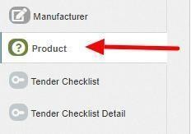

Figure 54 PRODUCT TAB

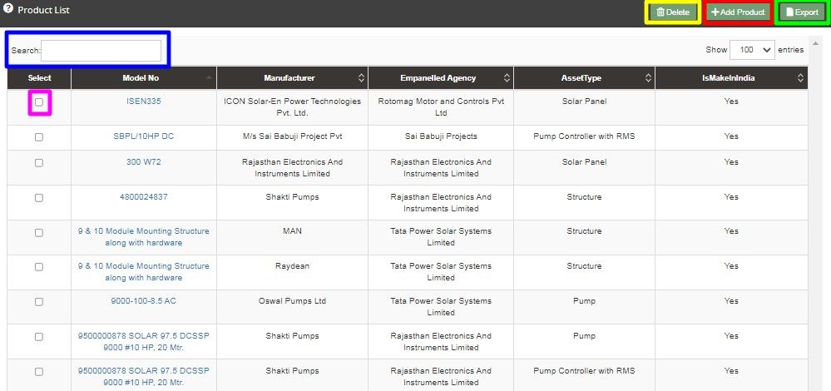

Figure 55 PRODUCT TAB DASHBOARD

Table 18 PRODUCT DASHBOARD EXPLANATION
Action | Functionality | Highlighted Colour | Type | Description
Search | Search Product | Blue | Text Box | Enter input to explore Product details
Delete | Delete Product | Yellow | Button | Select check box (highlighted in pink) and click on delete button to Delete Product details
Add Product | Register new Product | Red | Button | Register new Product by clicking on Add Product button
Export | CSV file for Product details | Green | Button | Download CSV file of Product details

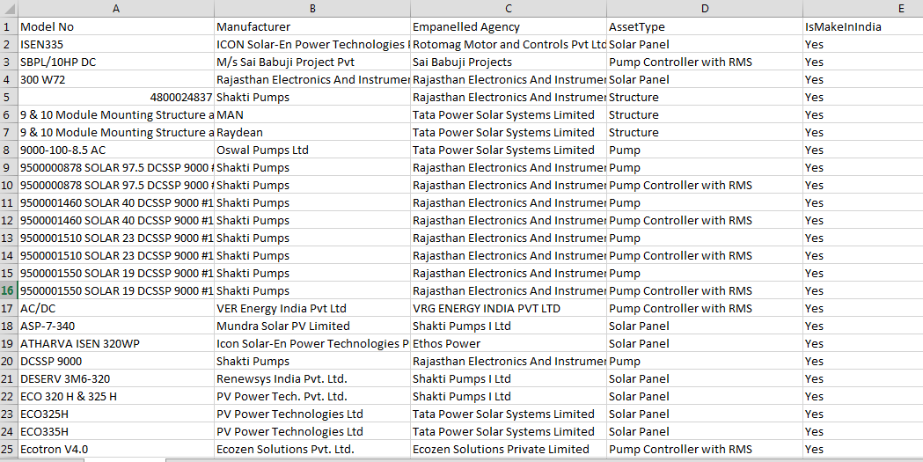

Figure 56 CSV OF PRODUCT DETAILS

    - User can register new Product by clicking on “Add Product” button. (highlighted in red in Figure 52)

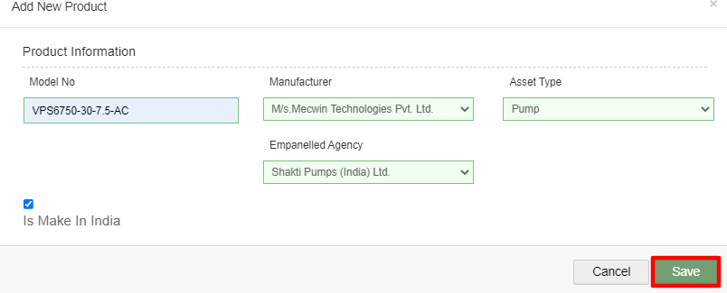

Figure 57 NEW PRODUCT DETAILS

Table 19 PRODUCT REGISTRATION FIELDS DESCRIPTION
Field | Input | Drop Down & Check Box Options | Mandato ry Field | Sample Values | Description
Model No. | Text | - | ✓ | VPS6750-30-7.5- AC | -
Empanelled Agency | Drop Down | - Sri Savitri Solar Pvt. Ltd  - Junna Solar System Pvt. Ltd. | ✓ | Junna Solar System Pvt. Ltd. | Selection of relevant Empanelled Agency
Manufacturer | Drop Down | - BHEL  - Ecozen Solutions Pvt LtdEthos Power Pvt. Ltd  - Junna Solar Systems Pvt Ltd | ✓ | Junna Solar Systems Pvt Ltd | Selection of the relevant manufacturer of the product
Asset | Drop Down | - Pump  - Solar Panel  - Pump Controller with RMS  - Structure | ✓ | Pump | Selection of the asset type
Is Make In India | Check Box | - | ✓ | - | Selecting this Check Box  conveys that product is made in India

    - After filling all the details, user has to click on the “Save” button (highlighted in red in above Figure 54) to register New Product.

REGISTRATION OF TENDER CHECKLIST

    - Tender Checklist is a template consisting of tender checklist items which acts similar to “guaranteed technical particulars (GTP)” and filled by empanelled agencies as self-declaration of compliance to tender specifications during lot creation and verified by the State Implementing Agency after the lot creation. (click here to know more)
    - SIA with Super Admin credentials can register new Tender Checklist by clicking on “Tender Checklist” tab as pointed in below Figure 55.
- Navigation Step :-
- Sign in on the State SEDM Portal
- Click on the Setting Module
- Click on Tender Checklist Tab

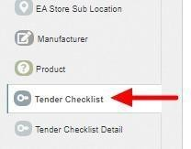
Figure 58 TENDER CHECKLIST TAB

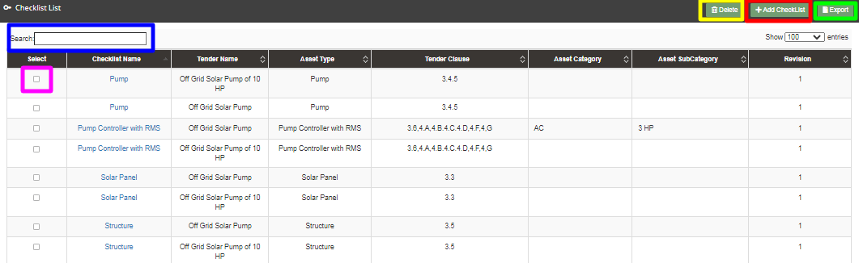

Figure 59 TENDER CHECKLIST TAB DASHBOARD

Table 20 TENDER REGISTRATION FIELDS DESCRIPTION
Action | Functionality | Highlighted Colour | Type | Description
Search | Search Tender Checklist | Blue | Text Box | Enter input to explore Tender Checklist

Delete | Delete Tender Checklist | Yellow | Button | Select check box (highlighted in pink) and click on delete button to Delete Tender Checklist
Add Checklist | Register new Tender Checklist | Red | Button | Register new Tender Checklist by clicking on Add Checklist button.
Export | CSV file for Tender Checklist | Green | Button | Download CSV file of Tender Checklist

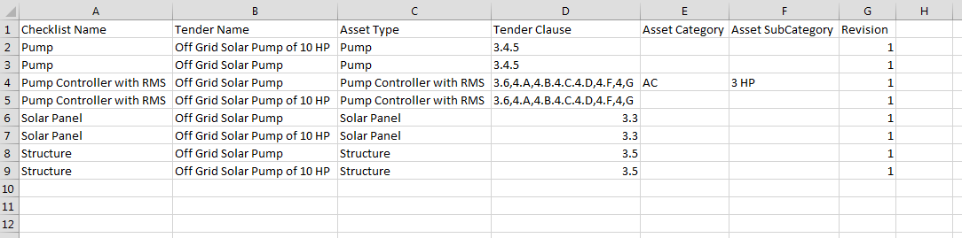
Figure 60 CSV OF TENDER CHECKLIST

    - User can register new Tender Checklist by clicking on “Add Checklist” button. (highlighted in red in Figure 56)

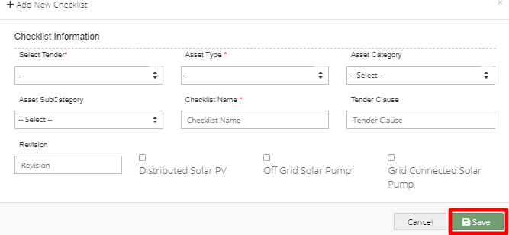
Figure 61 NEW CHECKLIST DETAILS

Table 21 TENDER CHECKLIST REGISTRATION FIELDS DESCRIPTION
Field | Input | Drop Down & Check Box Options | Mandatory Field | Sample Values | Description
Select Tender | Drop Down | - Off Grid Solar Pump  - Off Grid Solar Pump of 10 HP | ✓ | Off Grid Solar Pump  . | Selection of relevant Tender

Asset Type | Drop Down | - Pump  - Solar Panel  - Pump Controller with RMS  - Structure  - USPC | ✓ | Pump | Selection of the relevant asset type
Asset Category | Drop Down | - AC  - DC | ✓ | AC | Selection of the relevant asset category
Asset Sub Category | Drop Down | - 1 HP  - 2 HP  - 3 HP  - 5 HP  - 7.5 HP  - 10 HP | ✓ | 3 HP | Selection of the relevant asset sub category
Checklist Name | Text | - | ✓ | Pump | Name for identification of  checklist
Tender Clause | Text | - | ✓ | - | Reference tender clause of  corresponding tender
Revision | Text | - | - | - | Change in tender  specifications can be tracked using revision
Compone nt | Radio Button | - Distributed Solar PV (A)  - Off Grid Solar Pump (B)  - Grid Connected Solar Pump (C) | ✓ | Grid Connected Solar Pump (C) | Select PM-KUSUM Component

    - After filling all the details, user has to click on the “Save” button (highlighted in red in above Figure 58) to register New Checklist.

REGISTRATION OF TENDER CHECKLIST DETAILS

    - Tender Checklist Details is an individual checklist item which corresponds to tender specification/requirement. Empanelled agencies declare their compliance/deviation against ideal response. (click here to know more)
    - Super Admin can register new Tender Checklist Template by clicking on “Tender Checklist Detail” tab as pointed in below Figure 59.

- Navigation Step :-
- Sign in on the State SEDM Portal
- Click on the Setting Module
- Click on Tender Checklist Detail Tab

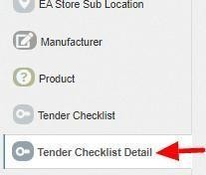

Figure 62 TENDER CHECKLIST DETAIL TAB

    - By clicking on the Tender Checklist Detail tab, a drop down will occur on the screen as shown in below figure, to select the Tender Checklist Name which was added in the “Tender Checklist” tab.

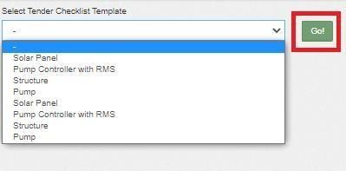
Figure 63 SELECT TENDER CHECKLIST TEMPLATE
    - After selecting the tender checklist template, user can see the Tender Checkliist Template dashboard as shown below.

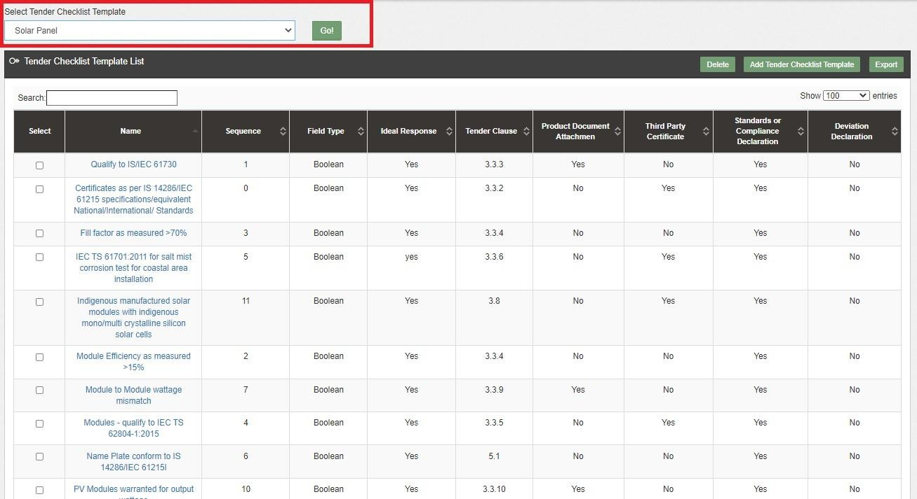

Figure 64 TENDER CHECKLIST TEMPLATE DASHBOARD

Table 22 TENDER CHECKLIST TEMPLATE DASHBOARD EXPLANATION
Action | Functionality | Highlighted Colour | Type | Description
Search | Search Tender Checklist Template | Blue | Text Box | Enter input to explore Tender Checklist Template
Delete | Delete Tender Checklist Template | Yellow | Button | Select check box (highlighted in pink)  and click on delete button to Delete Tender Checklist Template

Add Tender Checklist  Template | Register new Tender Checklist Template | Red | Button | Register new Tender Checklist Template  by clicking on Add Tender Checklist Template button
Export | CSV file for Tender Checklist Template | Green | Button | Download CSV file of Tender Checklist Template

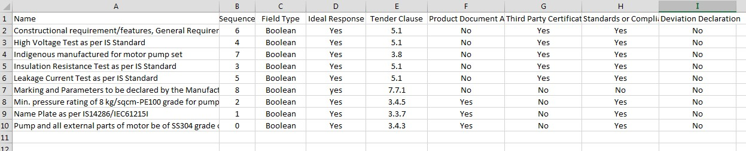

Figure 65 CSV OF TENDER CHECKLIST TEMPLATE

    - User can register new Tender Checklist Template by clicking on “Add Tender Checklist Template” button. (highlighted in red in Figure 61)

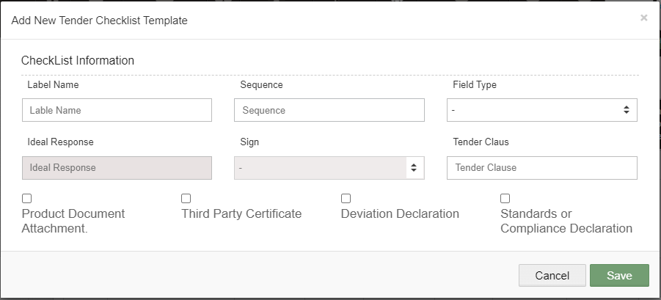

Figure 66 NEW TENDER CHECKLIST DETAILS

Table 23 TENDER CHECKLIST TEMPLATE REGISTRATION FIELDS DESCRIPTION
Field | Input | Drop Down & Check Box Options | Mandator y Field | Sample Values | Description
Label Name | Text | - | - | Constructional requirement/features,  General Requirements, Design features. | Identifier name to be given against checklist item
Sequence | Numerical | - | ✓ | 6 | Input the sequence number where this checklist item is to be displayed. Display of  the checklist item shall be ordered by sequence
Field Type | Drop Down | - Boolean  - String  - Drop Down  - Number | - | Boolean | Selection of the relevant field type of the tender checklist template

Ideal Response | Text | - | - | Yes | Input the ideal response  value expected against this checklist item
Sign | Drop Down | - | - | - | Select the sign as per expectation of ideal response
Tender Clause | Numerical | - | ✓ | 5.1 | Reference tender clause of corresponding tender
Additional required Input details against checklist item | Check Box | - Product Document Attachment  - Third Party Certificate  - Deviation Declaration  - Standard or Compliance Declaration | - | - Third Certificate  - Standard or Compliance Declaration | User need to submit corresponding documents/declaration as per selection

    - After filling all the details, user has to click on the “Save” button (highlighted in red in above) to register New Tender Checklist Template.

AUDIT TRAIL

    - Audit Trail serves the purpose to store the details of the person that make last update on State SEDM Platform.
    - SIA with Super Admin credentials can view the audit trail in “Setting” Menu.

- Navigation Step :-
- Sign in on the State SEDM Portal
- Click on the Setting Module
- Click on Audit Tab

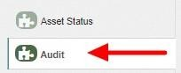

Figure 67 AUDIT TAB

    - By clicking on the Audit tab, the screen along with three filters i.e. Select District, Select Space (modules) and date range will appear as shown in below Figure 65.

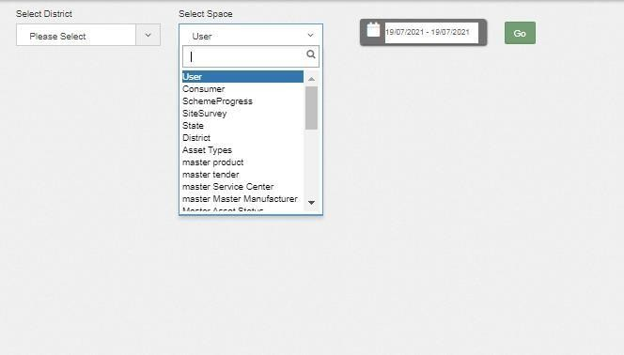

Figure 68 AUDIT TAB FILTERS

    - By selecting any particular district and Space (modules) against the selected district and date range, Super Admin can get the details about last updates made in particular selected Space (module) as shown in below Figure 66.

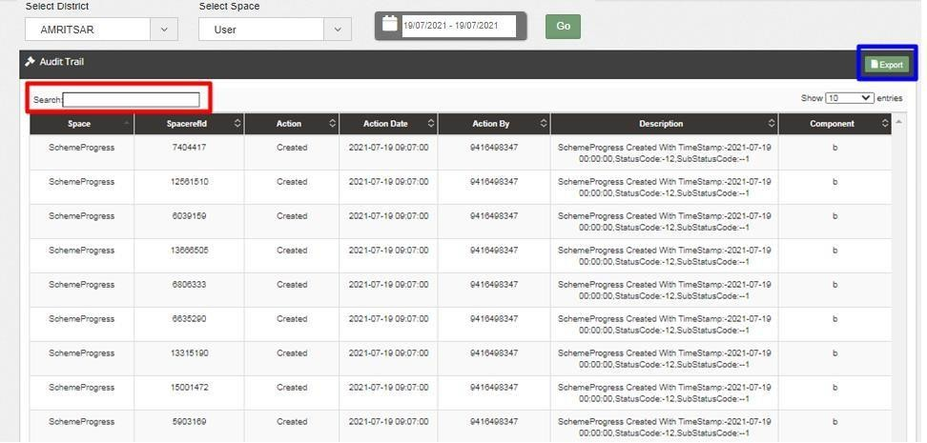

Figure 69 AUDIT DASHBOARD (APPLIED FILTERS)

    - As shown in above Figure 66, filtered dashboard by selecting District : Amritsar, Space : Scheme Progress and date range, one can find details like the person’s registered username (shown as phone numbers in above Figure 66) who had made updates in scheme progress, the date on which updates was made, the action he made while updating Scheme Progress, etc.
    - User can search for specific detail by entering input in “Search” box. (highlighted in red in Figure 66)
    - User can download a csv file (refer Figure 67) of filtered Audit details by clicking on export button. (highlighted in blue in Figure 66)

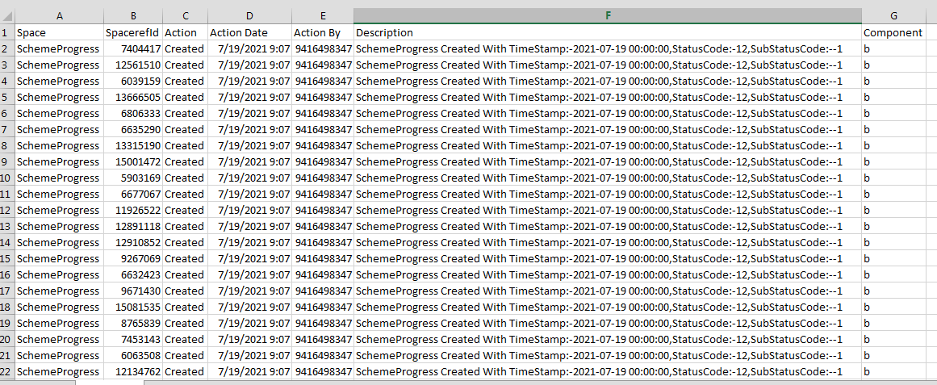

Figure 70 AUDIT DETAILS – CSV FILE

APPLICATION WORKFLOW STAGES

  - List of Responsible Users Of TN SEDM Portal who will be responsible for the below mentioned Workflow Stages :
- Sub Division Officer (SDN)
- Head Officer (HO)
- Empanelled Agency (EA)

Table 24 FARMER APPLICATION WORKFLOW STAGES
Consumer Functionality Name | Description | Responsibility
No of Solar Plants | It gives information about how many solar plants are planted | SIA/SNA/DISCOM
Plant Location | This gives us information about location of plant | SIA/SNA/DISCOM
LOA award | Selecting this Functionality will provide the access to update issue of LOA to the beneficiary/developer. | SIA/SNA/DISCOM
PPA signing | Selecting this Functionality will provide the access to  update the PPA agreement between the developer and the DISCOM/SIA | SIA/SNA/DISCOM
Financial Clearance | Selecting this Functionality will provide the access to update the Financial Clearance between  beneficiary/developer and DISCOM/SIA | SIA/SNA/DISCOM
Installation & Completion | This entry demonstrates that at which date solar plant is established | SIA/SNA/DISCOM
Electrical Inspector and Certificate received | This entry demonstrates that inspection is done and district officer gets certificate | SIA/SNA/DISCOM
Export meter connected & Permission received | Meter is connected with plant and permission received . | SIA/SNA/DISCOM
Testing, Comissio  ning, & synchronization | This functionality provides updates about testing, commissioning and synced data | SIA/SNA/DISCOM
Plant Charged | Plant is charged | SIA/SNA/DISCOM

Go live with RMS Data | District officer can get information of live data | SIA/SNA/DISCOM
On Hold | This step demonstrates that application is on hold | SIA/SNA/DISCOM

CONSUMER/FARMER APPLICATION REGISTRATION

  - The Consumer/Farmer Management module of SEDM is focused towards Consumer/Farmer registration, setting up of Consumer/Farmer profile and to provide the application updates, all at one place
  - Below are the authorized users for Application registration :
- State Implementing Agency (SIA)
  - Sub Division Officer (SDN)
  - Head Officer (HO)
  - DISCOM
  - SIA/SNA

- Navigation Steps for Consumer/Farmer application Registration :-
- Sign in on the State SEDM Portal
- Click on the “Details” on Consumer Module as shown in below Figure 68 Click on the “Add Farmer” button

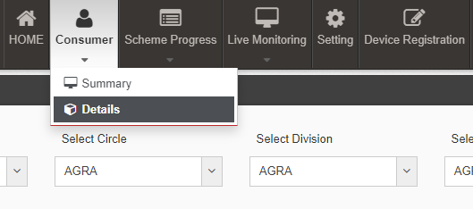
Figure 71 DETAILS

- Select the discom from where the new farmer belongs from and click on the “GO” button as shown in the below Figure 69 and Figure 70

Figure 72 SELECT DISCOM

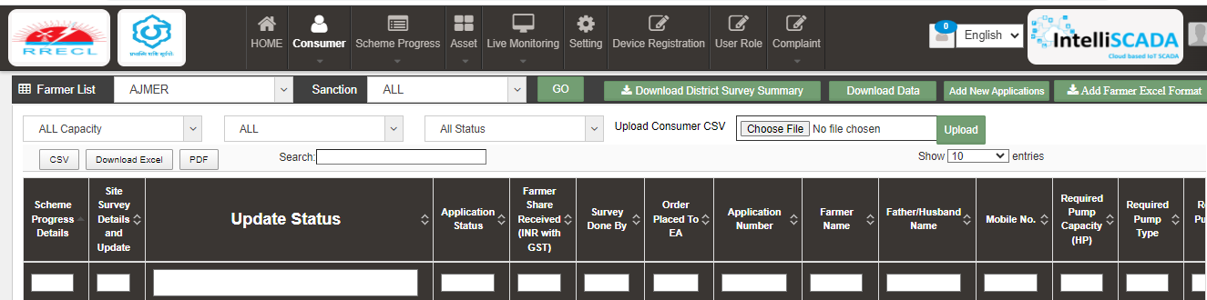
Figure 73 ADD FARMER BUTTON

  - Click on the “Add Plant” button as highlighted in red in the above Figure 71.

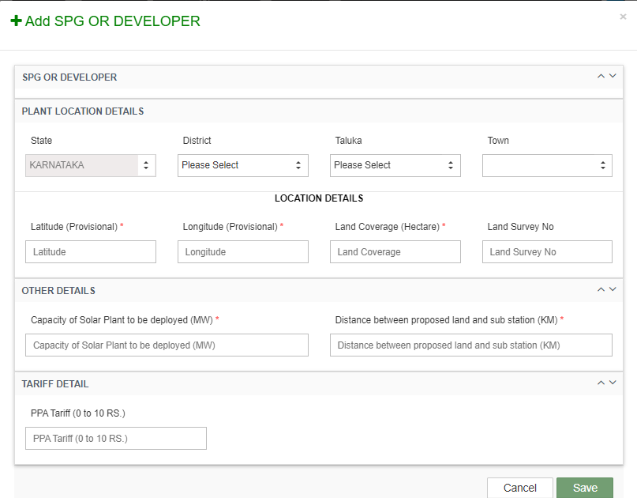

Figure 74 ADD FARMER FORM

  - After clicking on the “Add Plant” button, a screen will appear as shown in above Figure 72.
  - Multiple sections are there for filling out the application details.
  - User has to click on the section name (highlighted in red in above Figure 72) to open the section of the form.

SPG OR DEVELOPER

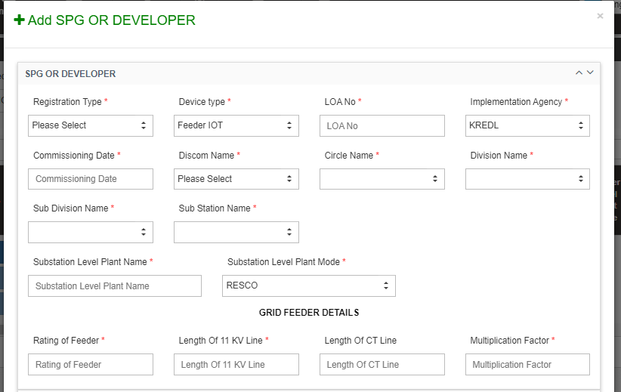
Figure 75 SPG OR DEVELOPER

Table 25 APPLICATION AND CONSUMER DETAILS
Field | Input | Drop Down Options | Mandat ory  Field | Sample Values | Description
Registration Type | DROPDO WN | Plant DT  FARMER | ✓ | Plant | This functionality describes registration type of dropdown
Device type | Drop Down | - FEEDER IOT | ✓ | FEEDER IOT | This functionality describes type of device
LOA NUMBER | TEXT |  | ✓ | 123 | This functionality provides LOA number of farmer.
Implementation Agency | Drop Down | - RRECL | ✓ | RRECL | This functionality provides facility to select implementing agency
Commissioning date | Text | - | - | 02/04/2023 | This functionality presents date of commission
Discom Name | Drop Down | - ddi- |  |  | This functionality provides facility to select discom
Circle Name | Drop Down | - circle 1  - circle 2  - circle 3 | ✓ | - circle 3 | This functionality provides facility to
Circle Name | Drop Down |  | ✓ | - circle 3 | select Circle name
Division Date | Drop Down | - Division 1  - Division 2  - Division 3 |  | - - Division 2 | This functionality provides facility to select DIVISION name
Sub Division Name | Drop Down | - Subdivision 1  - Subdivision 2  - Subdivision 3 | ✓ | - Subdivision 3 | This functionality provides facility to select SUB DIVISION name
Sub station name | Drop Down | - Substation 1  - Substation 2 | ✓ | - Substation 1 | This functionality provides facility to select sub station name
Substation level plant mode | Drop Down | - RESCO  - CAPEX | ✓ | CAPEX | This functionality provides facility to select sub station level plant mode  name
Substation level Plant Name | Text |  | ✓ |  | Enter the name of substation level plant

- Grid Details
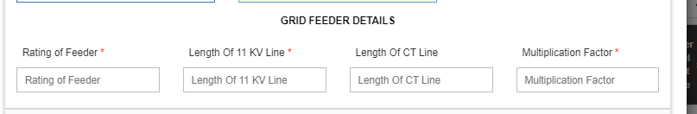
Figure 76 Grid Feeder Details

Field | Input | Drop Down Options | Mandatory Field | Sample Values | Description
Rating of feeder | Text | - | ✓ |  | Enter ratings for feeder
Length of KV line | Text | - | ✓ |  | Enter length of KV line
Length of CT line | Text | - |  |  | Enter length of CT line
Multiplication Filter | Text | - | ✓ |  | Enter multiplication factor
PLANT LOCATION DETAILS
State | Default | - |  | RAJASTHAN | -
District | Drop Down | - DISTRICT 1  - DISTRICT 2  - DISTRICT 3 |  | - DISTRICT 3 | This District selection is for the farmer’s residence district
Taluka | Drop Down | - TALUKA 1  - TALUKA 2  - TALUKA 3 | - | - TALUKA 3 | This taluka selection is for the farmer’s residence taluka
Town | Drop Down | - TOWN 1  - TOWN 2  - TOWN 3 | - | TOWN 3 | This town selection is for the farmer’s residence town

Latitude | Text | - | ✓ | 20.989898 | Enter latitude
Longitude | Text | - | ✓ | 76.987654 | Enter longitude
Land coverage | Text | - | ✓ | 2 | Enter land coverage
Land survey number | Text | - |  | 101 | Enter land survey number

Table 27 OTHER DETAILS
Field | Input | Drop Down Options | Mandatory Field | Sample Values | Description
Capacity of solar plant to be deployed | Text | - | ✓ | 2 | Enter value of Capacity of solar  plant to be deployed
Distance between  proposed land and sub station | Text | - | ✓ | 2 | Enter value of Distance between proposed land and sub station

Table 28 TARIFF DETAILS
TARIFF DETAILS
PPA Tariff (0 to 10 RS.) | Text | - | ✓ | 2 | Enter value between 0 to  10
 |  | -

- Communication Details : Consumer/Farmer’s Residential Details
- Location Details : Farm site location where pump will be installed
- Both details may vary.

PLANT LOCATION DETAILS

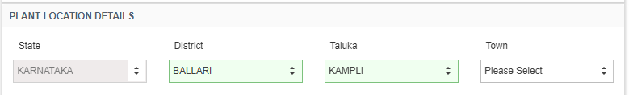

Figure 77 PLANT LOCATION DETAILS

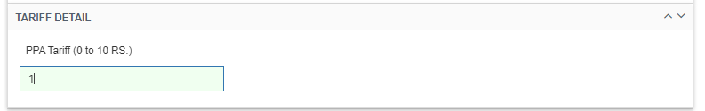
Figure 78 TARIFF DETAILS

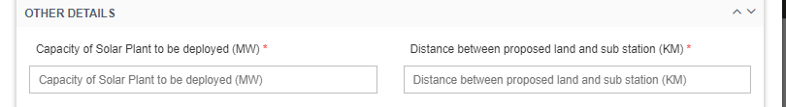
Figure 79 OTHER DETAILS

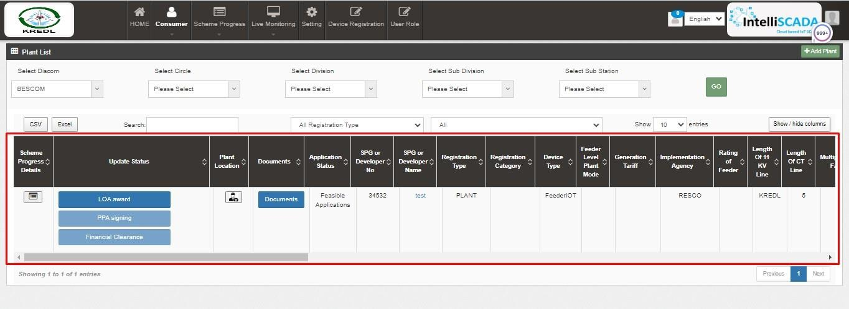

Figure 80 DETAIL DASHBOARD

- After application registration, new application will be entered in the consumer/farmer details dashboard as fresh entry (as highlighted in red above Figure 83) whose application scheme progress is yet to commence.
- Details dashboard consists following data columns :

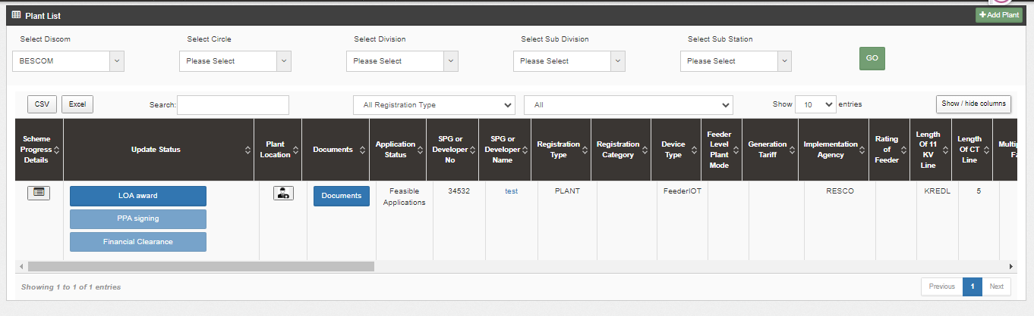

Figure 81 CONSUMER DETAIL DATA COLUMNS (I)

Consumer Details Dashboard Explanation

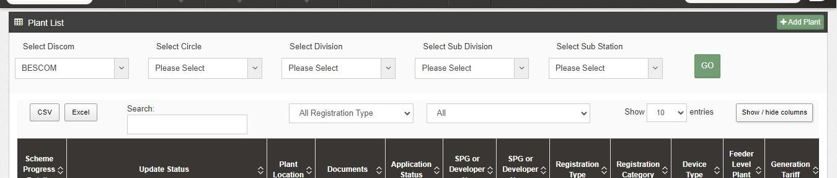

Figure 82 CONSUMER/FARMER DETAIL DASHBOARD

The “Add Plant” button highlighted in red box can be used to register a new plant application
  - Use filters highlighted in blue box to get the list of a particular application as per the requirement.
  - After selecting options in the filter clink on “GO” button highlighted in green box to apply the filters.
  - To track or see the progress/record of any particular application click on icon under “Scheme progress Details” highlighted in purple box in first column..
  - To view or download the documents click on blue button “Documents” highlighted in BLUE box under Documents column in fourth column.
  - To view the complete details of the applicant click on the “Farmer name” highlighted in purple box under Farmer Name in ninth column.

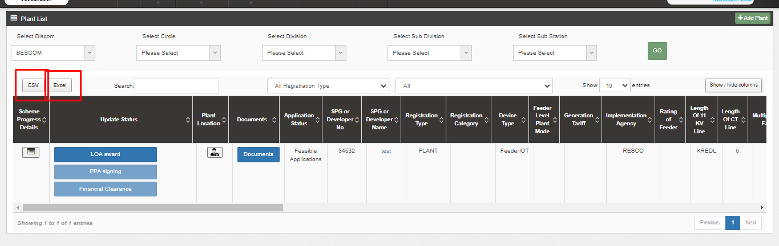
Figure 83 DETAILS DASHBOARD EXCEL FILE (II)
- The user can download the displayed data in three formats “CSV, Excel and PDF” highlighted in red box.

- Figure 86, by clicking onto the orange highlighted icon first column of Consumer Details dashboard, the user can view the chronological data for scheme progress details of any individual farmer. (as shown in below Figure 89)

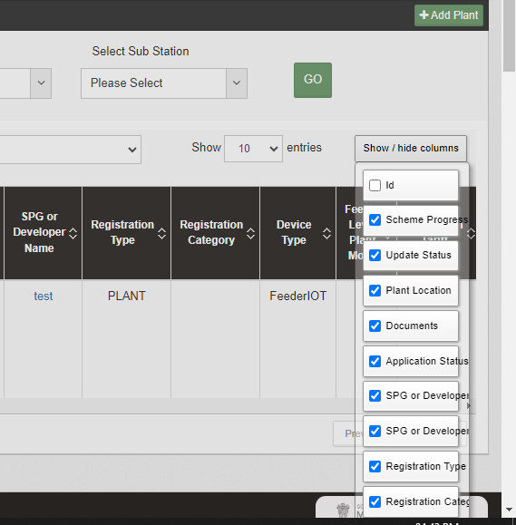

Figure 84 show and hide button

  - Similarly, by clicking on the icon (highlighted in pink in Figure 86) in the second column, the user can view the site survey details of the consumer/farmer as well as take action against individual farmer’s application and also can upload Site Photographs and Farmer Consent Form.

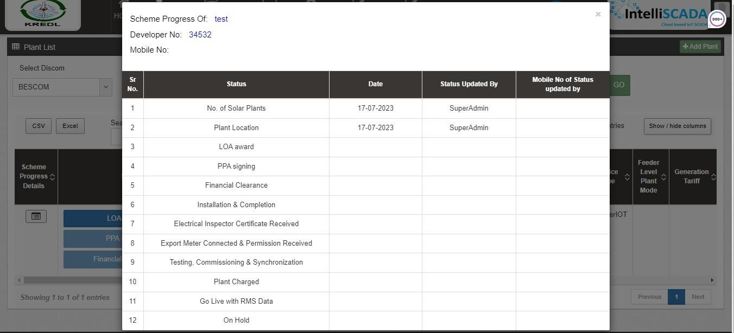

Figure 85 SITE SURVEY DETAIL OF CONSUMER/FARMER

- At the end of the report form, user can see 3 button options (in above Figure 90) – Hold, Accept, and Reject. These buttons are solely under the authorisation of Head Office or District Officer or District Office.

No of Solar Plants
  - Below are the authorized users to Authenticate the application :
- State Implementing Agency (SIA)
  - Sub Division Officer (SDN)
  - Head Officer (HO)
- Navigation Steps to change application status Authentication :-
- Sign in on the State SEDM Portal
- Click on the “Details” on Consumer Module as shown in below figure

This entry is shown in scheme progress detail, while user fills form .

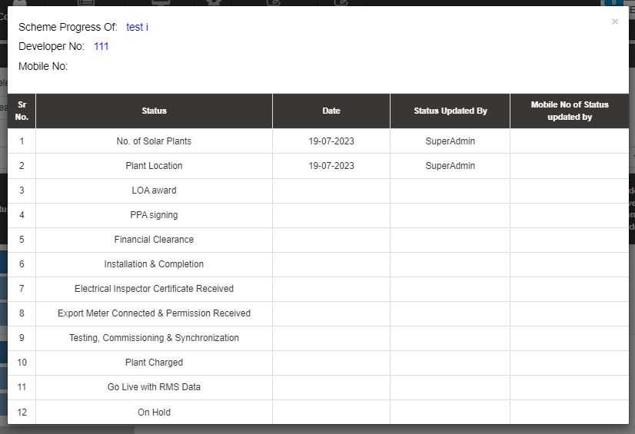

Figure 86 NO OF SOLAR PLANTS

When farmer is saved, there is automatic entry against this field

PLANT LOCATION

  - Below are the authorized users to update the status Technical Verification:
- State Implementing Agency (SIA)
  - Sub Division Officer (SDN)
  - Head Officer (HO)

Figure 87 PLANT LOCATION

Figure 88 PLANT LOCATION

- Navigation Steps to change application status Authentication :-
- Sign in on the State SEDM Portal
- Click on the “Details” on Consumer Module as shown in below fig.
- “LOCATION PLANT” entry is mentioned in scheme progress details, while user fills form.

LOA Awards

  - Below are the authorized users for Feasible Application:
    - State Implementing Agency (SIA)
    - Sub Division Officer (SDN)
    - Head Officer (HO)

- Navigation Steps to change application status “Feasible Application” :-
- Sign in on the State SEDM Portal
- Click on the “Details” on Consumer Module as shown in below

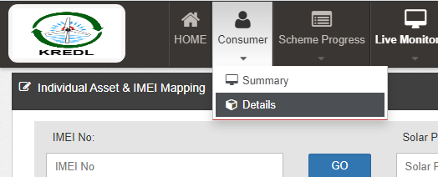

Figure 89 consumer detail

- Click on icon shown in below figure to check the Technical details of the site:
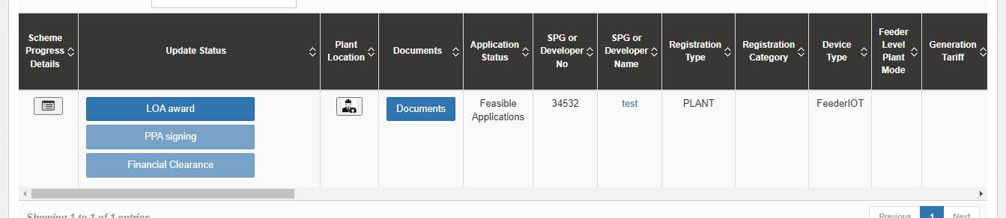
Figure 90 LOA AWARD

- Click on “Accept” to update the LOA Award Status :

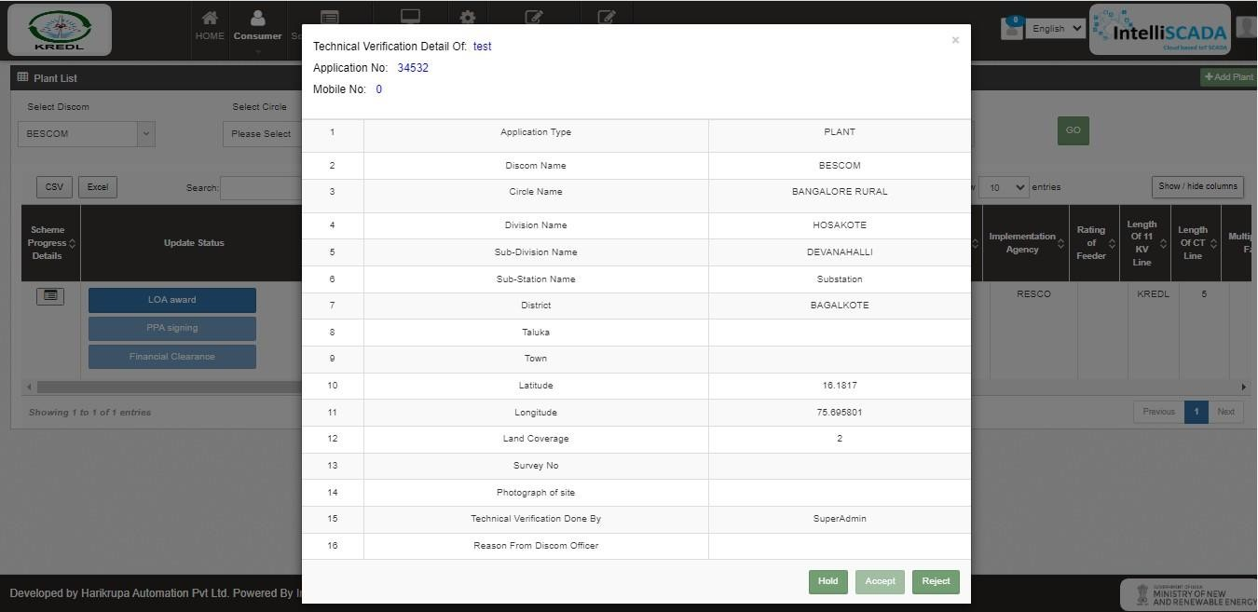

Figure 91 PLANT LOCATION

Note:
- The authorized user will Site Resurvey / Accept / Reject / Hold the application according to the site survey details.
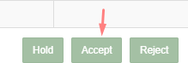

FIGURE 91 APPLICATION ACCEPT BUTTON

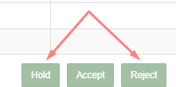
FIGURE 92 APPLICATION HOLD-REJECT BUTTON

- To put application on hold or to reject the application, user has to click on the “Hold” or “Reject” button (pointed in red in above Figure 92) and have to give the reason for the same.

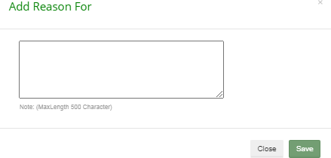

FIGURE 93 REASON FOR APPLICATION HOLD/REJECT

17 LOA Award

  - Below are the authorized users for Farmer Share Received :
    - State Implementing Agency (SIA)
      - Sub Division Officer (SDN)
      - Head Officer (HO)
- Navigation Steps to change application status LOA Award :-
- Sign in on the State SEDM Portal
- Click on the “Details” on Consumer Module as shown in below figure

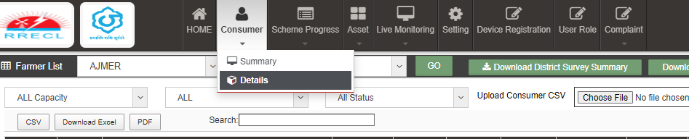

- Click on “LOA Award“ in the update status

- In Details dashboard as shown in below figure, Consumer/Farmer details are displayed along with the blue buttons of Status in third column.

18 PPA Signing
- Below are the authorized users for Order Placed to EA :
  - State Implementing Agency (SIA)
    - Sub Division Officer (SDN)
    - Head Officer (HO)
- Navigation Steps to change application status PPA Signing:-
- Sign in on the State SEDM Portal
- Click on the “Details” on Consumer Module as shown in below Figure 96 Details

- After LOA Award, authorized users has to change the status “PPA Signing”.
- In Details dashboard as shown in below figure, Consumer/Farmer details are displayed along with the blue buttons of Status in second column.

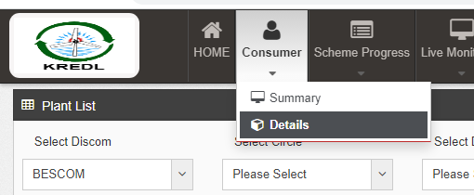

FIGURE 96 DETAILS
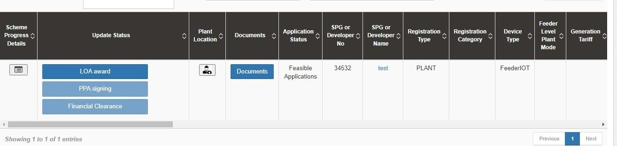
Figure 92
Figure 93 PPA SIGNING

Financial Clearance
  - Below are the authorized users for Financial Clearance :
    - State Implementing Agency (SIA)
      - Sub Division Officer (SDN)
      - Head Officer (HO)
- Navigation Steps to change application status PPA Signing:-
- Sign in on the State SEDM Portal
- Click on the “Details” on Consumer Module as shown in below Figure 96 Details

- After PPA Signing, authorized users has to change the status “Financial Clearance”.

Figure 94 FINANCIAL CLEARANCE

LIVE MONITORING

- The Live Monitoring Module on SEDM Platform gives the users a dynamic functionality to monitor and assess the scheme statistics as well as the functioning of the solar plant/pump efficiently, all of this from a single window.

  - Navigation Steps: -
  - Sign in on the State SEDM Portal
  - Click on the ‘Live Monitoring’ option on the Title Bar of the SEDM Portal Dashboard
  - Navigate “Dashboard” (as shown in Figure 102)

    - Sign In >> Live Monitoring >> Dashboard

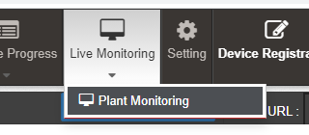
Figure 95 LIVE MONITORING DASHBOARD OPTION

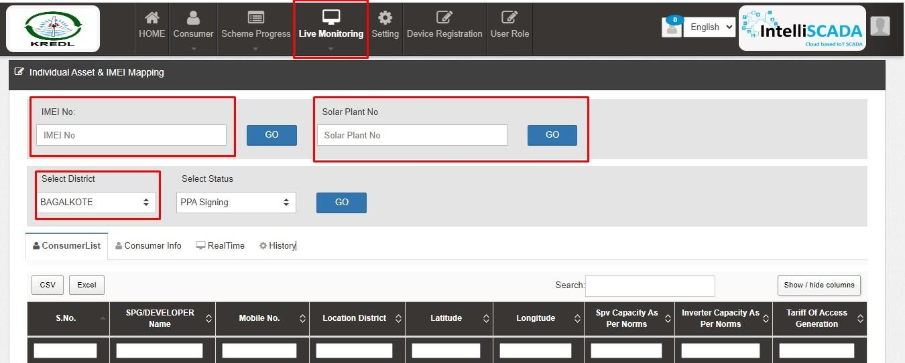

Figure 96 LIVE MONITORING

FIGURE 103 LIVE MONITORING DASHBOARD
    - Last Updated Time Stamp (highlighted in yellow in above Figure 103) It is the start date when the system became operational.
      - This time stamp updates every 15 minutes in Live Monitoring Dashboard on State SEDM Platform and consequently, data of live monitoring dashboard gets updated every 15 minutes.
    - Empanelled Agency Filter (highlighted in blue in above Figure 103)
      - User can view live monitoring dashboard data of all empanelled agencies or else, can view data empanelled agency wise also by filtering out empanelled agency.
    - Consumer Details (highlighted in red in above Figure 103)
      - By clicking on the “Consumer Details” button, user can view a screen where the consumer details as well as their corresponding RMS details (last updated) will be displayed and can also edit consumer’s RMS latitude-longitude in this screen only just for once.

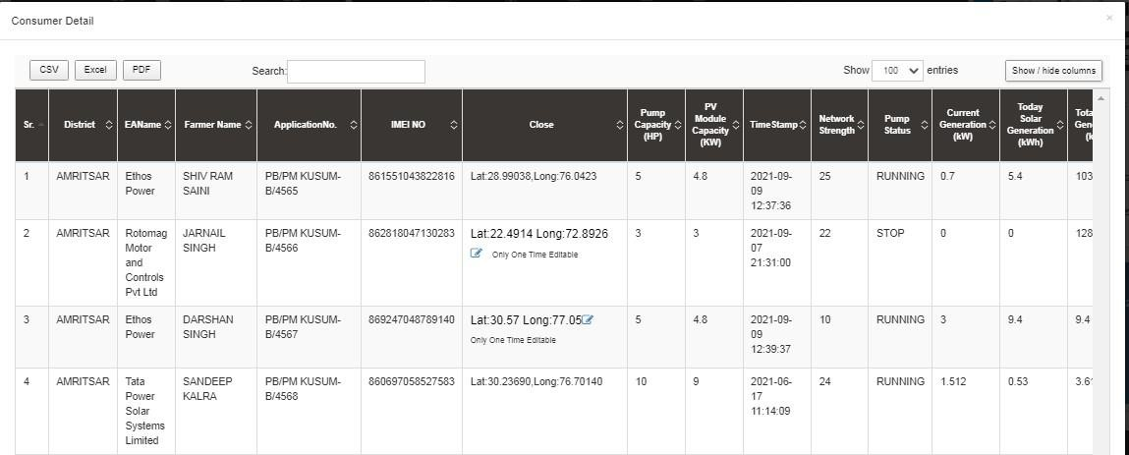

Figure 97 LIVE MONITORING DASHBOARD

- User can change RMS latitude and longitude by clicking on edit icon (highlighted in red in above Figure 104) and in below Figure 106 is shown how to change the RMS latitude and longitude.

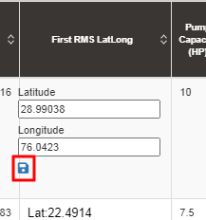

Figure 98 UPDATE RMS LATITUDE - LONGITUDE

- After entering new RMS latitude and longitude, user has to click on the save icon (highlighted in red in Figure 103) to update the RMS latitude-longitude.

NOTE: RMS Latitude-Longitude can be updated only once and not more than that.

  - Below are the parameters covered in Live monitoring dashboard (highlighted in green in above Figure 103) :

Total Standalone Pumps
    - It reflects the total numbers of applications whose application status is updated to “Installation & Verification done”.

Total Pump Capacity
    - It reflects the total sum of capacity (HP) of total standalone pumps.

Total Module Capacity
    - It reflects the total sum of SPV capacity of total standalone pumps. (SPV Capacity as per EA rate card, click here
to know more)

Total RMS Integrated Pumps
    - It reflects the total number of pumps who had sent RMS data on the portal for the first time.

Total Solar Generation
    - It reflects the total cumulative Solar Generation of RMS Integrated pumps till today. (in terms of MUs i.e. Million Units)

Total Water Discharge
    - It reflects the total cumulative kilolitres of Water discharged from RMS Integrated pumps till today.

Total Pump Run Hours
    - It reflects the total cumulative hours that RMS Integrated pumps ran till today.

CO2 Reduction (TON)
    - CO2

Avg. Solar Generation per Pump
    - Formula : Total Solar Generation / Total RMS Integrated pumps

Avg. Water Discharge per Pump
    - Formula : Total Water Discharge / Total RMS Integrated pumps

Avg. Run Hours
    - Formula : Total Pump Run Hours / Total RMS Integrated pumps

  - Live Monitoring has three different coloured boxes (Red, Green and Blue as shown in Figure 103) are explained in below Table 35.

Table 30 LIVE MONITORING – EXPLANATION OF THREE BOXES
Box Name (Colour) | Sub Status | Description | Refer Figure 103 for below figures as an example
Communication Status (Red Box) | RMS Integrated Pumps | Displays Total RMS Integrated Pumps out of Total Pumps whose current status is Installation & Commission Done | 7808 (Total RMS Integrated pumps) / 12614 (Total Pumps  having current status Installation & Commission )
Communication Status (Red Box) | Invalid RMS Integrated Pumps | This sub status considers standard time of Total Pump running hours as 12 hours. If any pump from total RMS Integrated pumps runs  for more than standard hours than it falls in Invalid category | 1525 (Pumps ran more than standard hours) / 7808 (Total RMS Integrated pumps)
Communication Status (Red Box) | Connected Since Last 30 Mins (LIVE) | Displays Total no. of Pumps that are connected from last 30 mins out of Total RMS Integrated pumps | 2033 (Total Pumps connected  since last 30 minutes) / 7808 (Total RMS Integrated pumps)
Communication Status (Red Box) | Disconnected | Displays Total no. of Pumps that are disconnected out of Total RMS Integrated  pumps | 4250 (Total disconnected Pumps) /  7808 (Total RMS Integrated pumps)
Communication Status (Red Box) | Location Matched | Displays Total no. of pumps whose latitude- longitude (captured while Site Survey) matched with the latitude-longitude that RMS had sent along with the data for the first time  on the portal out of Total RMS Integrated pumps | 2956 (matched Latitude-Longitude)  / 7808 (Total RMS Integrated pumps)
Communication Status (Red Box) | Location Mismatched | Displays Total no. of pumps whose latitude- longitude (captured while Site Survey) mismatched with the latitude-longitude that RMS had sent along with the data for the first  time on the portal out of Total RMS Integrated pumps | 3327 (mismatched Latitude- Longitude) / 7808 (Total RMS Integrated pumps)
Operation Status of Live Pumps (Green Box) | Pumps in Run Mode | Displays Total no. of pumps that are currently running out of total no. of pumps that are  connected since 30 minutes (sub status given in red box) | 542 (Pumps currently running) / 2033 (Pumps connected since last 30 minutes)
Operation Status of Live Pumps (Green Box) | Pumps in Stop Mode | Displays Total no. of pumps that are currently not running i.e. stopped out of total no. of  pumps that are connected since 30 minutes (sub status given in red box) | 1470 (Pumps currently stopped) / 2033 (Pumps connected since last 30 minutes)
Operation Status of Live Pumps (Green Box) | Pumps in Protected Mode | Displays total no. of pumps that falls in below shown four categories (highlighted in red in below Figure 107) out of total no. of pumps | 21 (Invalid Pumps) / 2033 (Pumps connected since last 30 minutes)

 |  | that are connected since 30 minutes (sub status given in red box)
Utilization Factor for installed solar capacity (MV) (Blue Box) | Capacity Utilization Factor For Live Pumps (MV) | Displays total SPV capacity (MW) produced of total no. of pumps (currently in run mode - sub status given in green box) out of total SPV capacity as mentioned in the EA rate card (click here to know about SPV capacity as per EA rate card) | 1.79 (total SPV capacity (MW) produced of total no. of running pumps) / 12.37 (total SPV capacity as mentioned in the EA rate card) 1.79 / 12.37 * 100 = 14.46 % (percentage shown in blue box of  live monitoring dashboard in Figure 103)
 | Avg. Solar Generation per Pump (KW) 542 (Pumps  currently in run mode) | 1.79 (total SPV capacity (MW) produced of total no. of running pumps) / 542  (Pumps currently in run mode) * 1000 (to convert value from MW into KW) = 3.30  KW

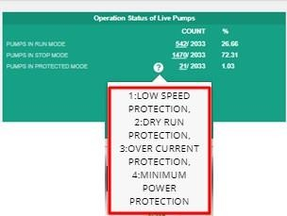
Figure 99 INVALID PARAMETERS OF GREEN BOX OF LIVE MONITORING DASHBOARD

  - Below are the brief points covered under map of Live Monitoring dashboard:

Monitoring of Live Parameters on Dashboard with Map View
- Navigation:
  - It is possible to navigate from state to district to individual Consumer/Farmer on a single page in the map view.
  - At state and district level, summary of parameters are displayed in a pop-up window.
- By clicking upon the green location icon on map (shown in Figure 103), a screen (refer ) will open that covers the following list of Important Parameters of particular district:

Standalone Solar Pumps
    - Total no. of Standalone Solar Pumps
    - Total Pump Capacity (HP)
    - Total Solar Module Capacity (Actual) (KW)

RMS Integrated Pumps
    - Total no. of RMS Integrated Pumps
    - Pumps in Run Mode
    - Pumps in Stop Mode
    - Pumps in Protection Mode
    - Current Solar Capacity Utilization of Pump in Run Mode (KW)

Indicators
    - Pump Run Hours
    - Solar Generation (kWh)
    - Water Discharged (Kiloliter)

- By clicking upon district name, user will get a broad view of selected district in which consumers/farmers of that district (in terms of green and red location icons, as shown in below will be displayed.
- Green Icon (Live) - Consumer/Farmer’s Solar Pump that is connected since 30 minutes.
- Red Icon (Not Live) - Consumer/Farmer’s Solar Pump that is disconnected.
- User can filter out the view by selecting any of the three status of Solar Pump.
- Also user can navigate back to the state view by clicking on state name.

SUMMARY

- Under the ‘Consumer’ tab title bar, there are two options in the drop-down menu. These options provide different views of application tracking and analysis.
- The first option is ‘Summary’ provides an overall Consumer Management Summary. This dashboard displays an organised flowchart which helps user to understand different stages of application processing and to view details about any specific EA if needed.

  - Navigation Steps: -
  - Sign in on the State SEDM Portal
  - Click on the ‘Consumer/Farmer’ option on the Title Bar of the SEDM Portal Dashboard
  - Click on the ‘Summary’ option from the drop-down menu
  - Go to Consumer and click on Summary

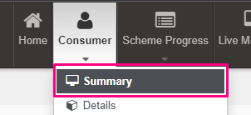

- Sign In >> Consumer >> Summary

Figure 100 CONSUMER/FARMER MANAGEMENT SUMMARY OPTION SELECTED ON CONSUMER/FARMER DASHBOARD

Description of each and every coloured boxes of application status as shown in the above image

    - Count of all application status will be incremented according to the status gets changed of the consumers/farmers by the authorized person.

Table 31 SUMMARY EXPLAINATION
Status | Image | Description | Want to know how to change status? (Click Ctrl + Click)
No. of Solar Plants | 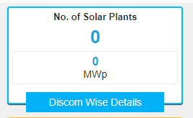 | It gives information about how many solar plants are planted
Plant Location | 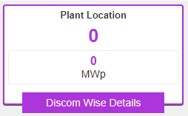 | This gives us information about location of plant
LOA Award | 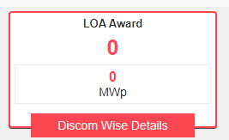 | Selecting this Functionality will provide the access to update issue of LOA to the beneficiary/developer.

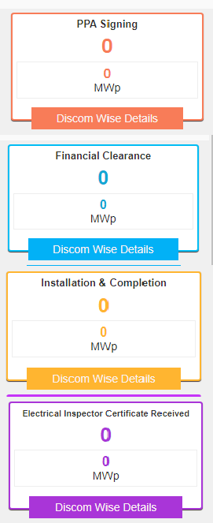
PPA Signing |  | Selecting this Functionality will provide the access to  update the PPA agreement between the developer and the DISCOM/SIA
Financial Clearance |  | Selecting this Functionality will provide the access to update the Financial Clearance between  beneficiary/developer and DISCOM/SIA
Installation & Completion |  | This entry demonstrates that at which date solar plant is established
Electrical Inspector Certificate Received |  | This entry demonstrates that inspection is done and district officer gets certificate
Export Meter Connected & Permission Received | 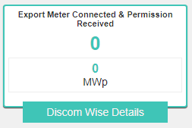 | Meter is connected with plant and permission received .

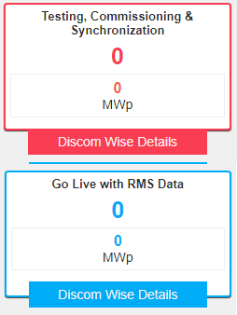
Testing, Commissioning & Synchronization |  | This functionality provides updates about testing, commissioning and synced data
Go Live with RMS Data |  | Destric officer can get live data.
On Hold | 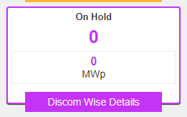 | Application is on hold. When some condition not right and some data not math on condition.

    - There are several DISCOMs that a user can choose from (pointed out in below Figure 109), depending on their analytical requirement or data studying.

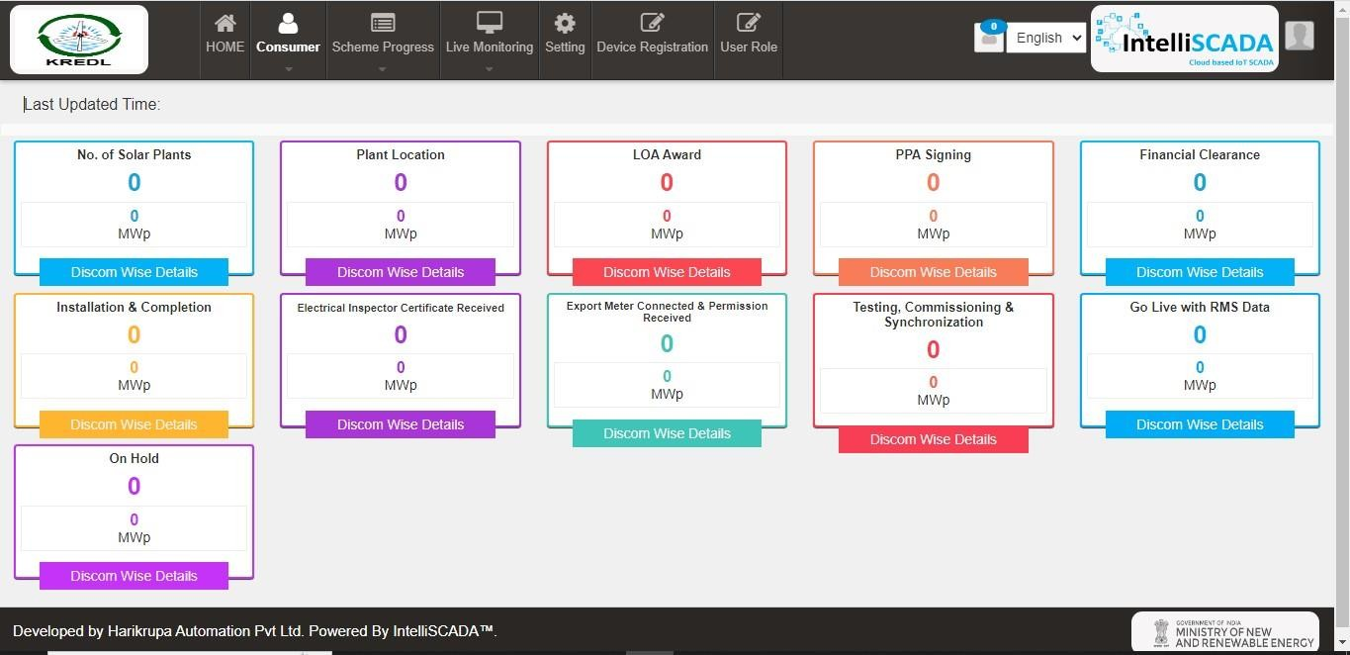

    - Each box label has a suitable name given to it which signifies the step at which the application of a user has reached at. It also provides the statistical numbers for this information, along with total solar installation capacity in kilowatts peak (kWp) generated in Horsepower (HP), for allocated users.
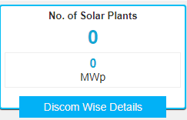

Figure 101 INDIVIDUAL APPLICATION STAGE

    - To get more details for every sub-division, users can click on the ‘Discom Wise Details’ button in the label box. It will display the screen shown below in Figure 113 :
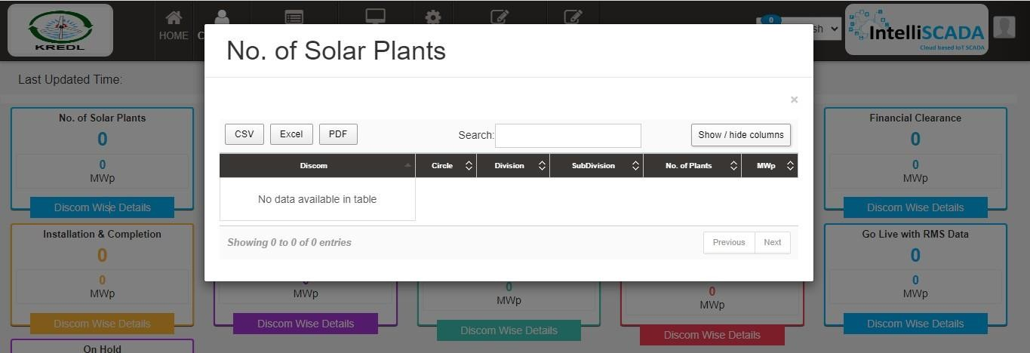

Figure 102 DISTRICT-WISE SUMMARY OF APPLICATIONS RECEIVED FOR VARIOUS PUMP MODELS REPORT

    - In this table, users can choose to show or hide columns as per their preference by selecting ‘Show / hide columns’ button on top right corner.

    - Additionally, users can search for their specific division or sub-division by inputting the relevant search query in the ‘Search’ dialogue box. (highlighted in red in below Figure 116)

_

SCHEME PROGRESS

    - The Scheme Progress Module of SEDM portal helps the users to track the progress of application with detailed information, to understand the user role management, to search for bulk queries, and to generate reports including the progress status and application workflow.

  - Navigation Steps: -
  - Sign in on the State SEDM Portal
  - Click on the ‘Scheme Progress’ option on the Title Bar of the SEDM Portal Dashboard

    - Sign In >> Scheme Progress

    - Below are the brief points covered under this module:

24 SCHEME PROGRESS REPORT
    - Navigation Steps: -
- Sign in on the State SEDM Portal
- Click on the ‘Scheme Progress’ option on the Title Bar of the SEDM Portal Dashboard
- Click on the ‘Reports’ option from the drop-down menu

      - Sign In >> Scheme Progress >> MIS Reports
      - With the Report feature in Scheme Progress Module on SEDM portal, the users can view and download various types of reports based on the input parameters of the filters provided.

      - Different Types of Reports are:
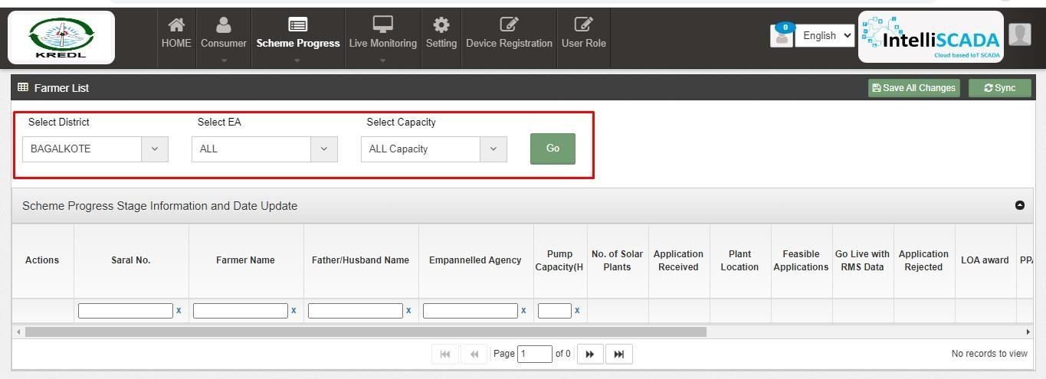
Figure 103 SCHEME PROGRESS/ DETAILS

YEARLY PROGRESS SUMMARY

      - Yearly Progress Summary to show PM-KUSUM scheme progress statistics with respect to years.
      - The filter options provided to the users are :
        - Select Empanelled Agency
        - Select District
        - Select Year
        - Result Type
        - Application Status Selection
        - Select sanction

Tabular View

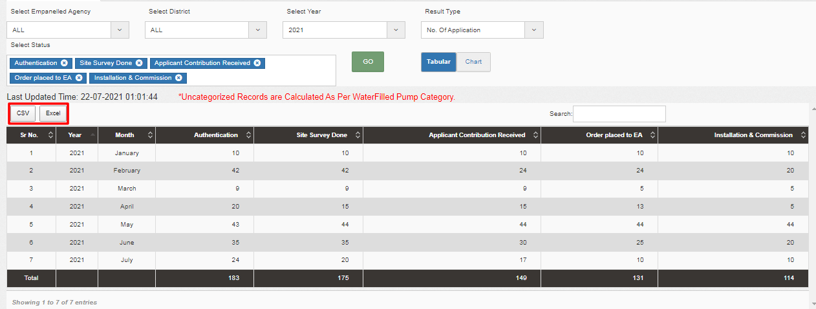

Figure 104 Yearly Progress Summary – Tabular view

Chart View

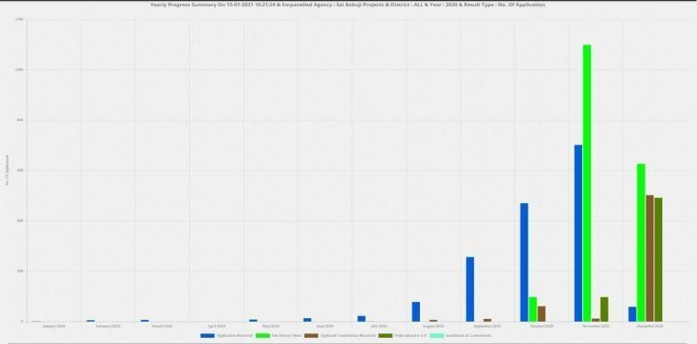

Figure 105 Yearly Progress Summary – Chart view

DISTRICT/DISCOM PROGRESS SUMMARY

      - District / Discom Progress Summary to show PM-KUSUM scheme progress statistics with respect to different districts of State.
      - The filter options provided to the users are :
        - Select Empanelled agency
        - Result Type
        - Select capacity
        - Select sanction

Tabular View
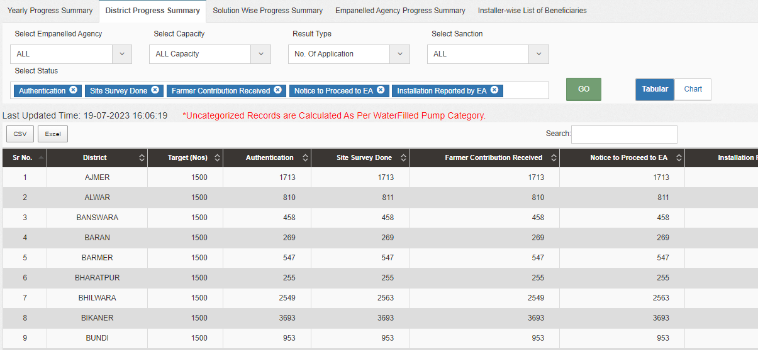

Figure 106 District Progress Summary- tabular view

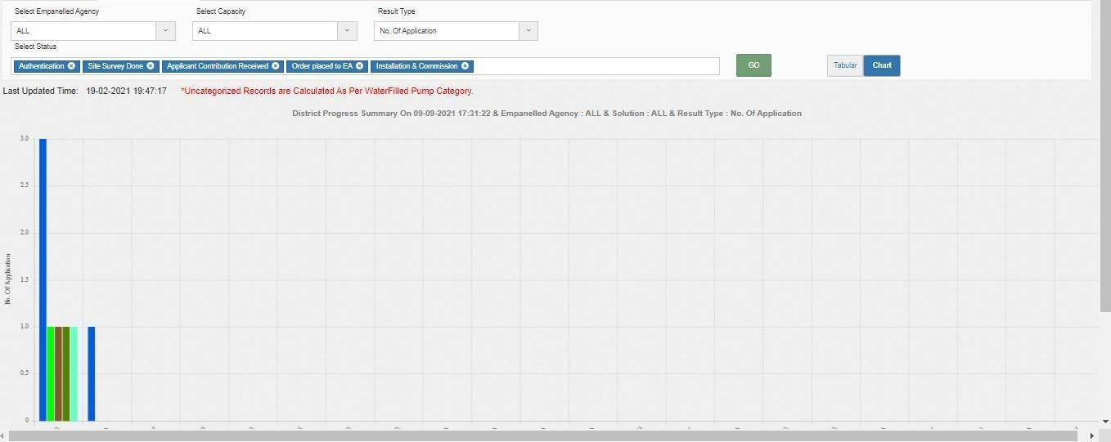
Chart View

Figure 107 DISTRICT PROGRESS SUMMARY – CHART VIEW

SOLUTION WISE PROGRESS SUMMARY

      - Solution wise Progress Summary to show PM-KUSUM scheme progress statistics with respect to pump.
      - The filter options provided to the users are :
        - Select Empanelled Agency
        - Select District
        - Select Pump Capacity
        - Select pump type
Select pump sub type
        - Select pump category
        - Select sanction
        - Select status

Tabular View

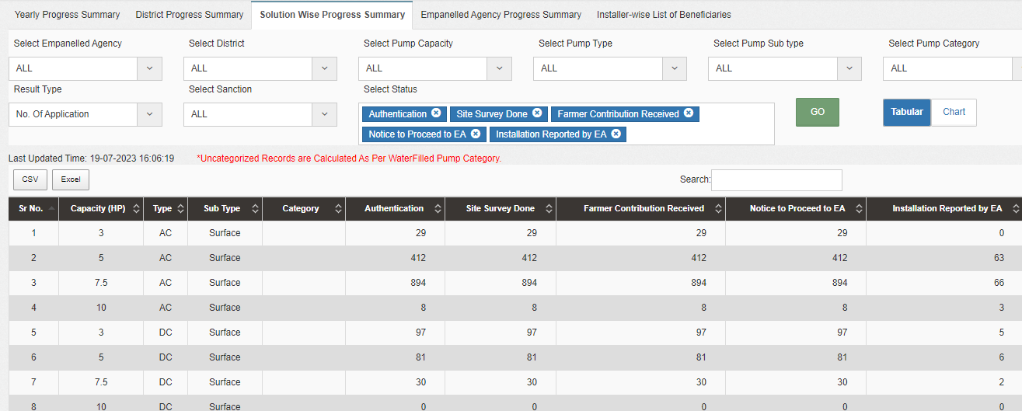
Figure 108 Tabular view of solution wise

Chart View

Figure 109 chart view solution wise

EMPANELLED AGENCY PROGRESS SUMMARY

      - Empanelled Agency Progress Summary to show PM-KUSUM scheme progress statistics with respect to Empanelled Agency.
      - The filter options provided to the users are

        - Select District
        - Select Pump Capacity
        - Result type
        - Select sanction

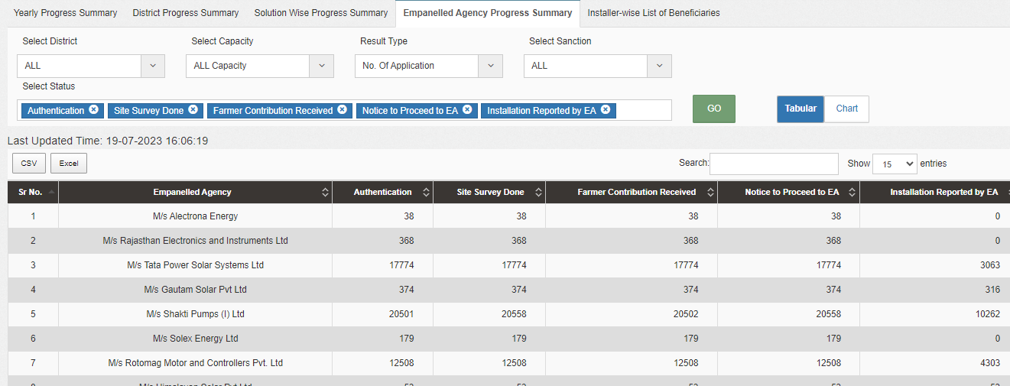
Figure 110 tabular view Empanelled agency wise

chart View
Figure 111 Chart view Empanelled agency wise

Installer wise list of beneficieries

      - Installer wise list of beneficieries to show PM-KUSUM scheme progress statistics with respect to Installer.
      - The filter options provided to the users are

        - Select Empanelled Agency

        - Select sanction

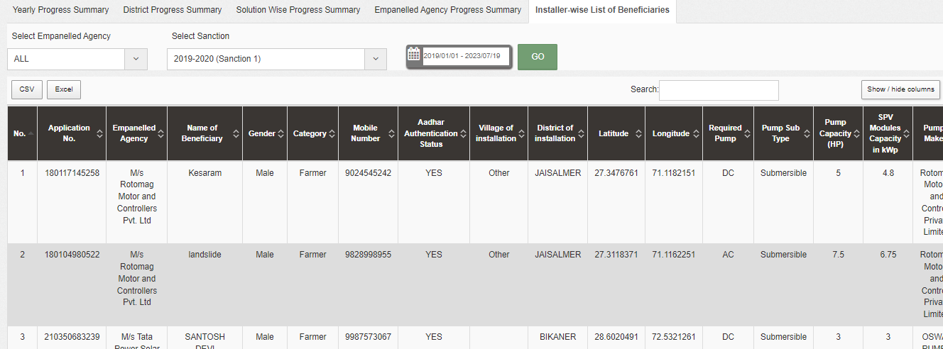

Figure 112 tabular view Installer wise

chart View
Figure 113 chart view Installer wise

SIGN OUT

  - The users can log out or sign out from the State SEDM Portal by following 2 methods.
  - Either by clicking onto the ‘User’ icon, present at the top right corner on the title bar of the SEDM Portal (pointed in below Figure 123) and then selecting the option of ‘Logout’ (highlighted in BLUE in below).

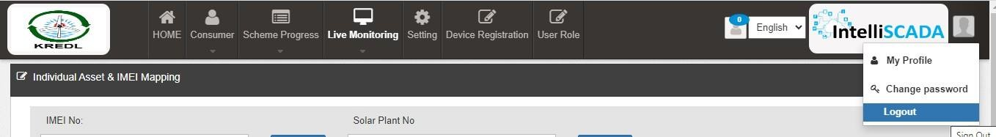

Figure 114 LOGOUT

  - The second method is to first click onto the ‘Home’ page button on the title bar of the SEDM Portal (pointed in red in below Figure 124), and then on the Home Page selecting the option of ‘Sign Out’ present in the form of a blue coloured button on the top right corner of the page (highlighted in red in Figure 125)
Figure 115 HOME SELECTED

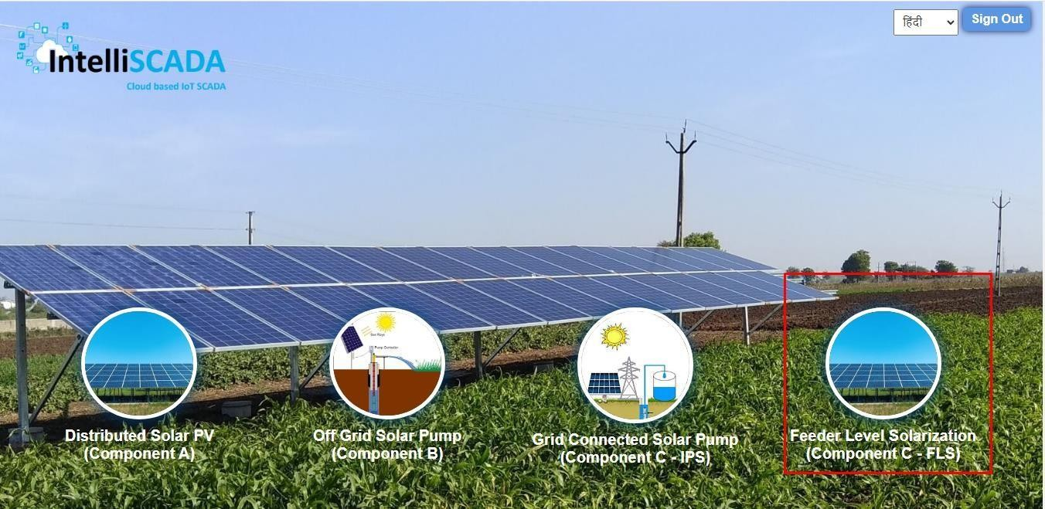

Figure 116 SIGN OUT

SUPPORT TEAM CONTACT DETAILS

Email - HO[DOT]LUCKNOW[AT]UPBVN[DOT]ORG

ANNEXURE-I (IMEI NUMBER REGISTRATION)

IMEI NUMBER REGISTRATION

  - Navigation Steps: -
- Sign in on the State SEDM Portal
- Click on the “Device Registration” option on the Title Bar of the SEDM Portal Dashboard
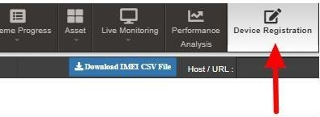
Figure 117 DEVICE REGISTRATION

  - IMEI no. can be registered in two ways :
    - Bulk Registration of IMEI nos. by uploading CSV file.
    - Registration of single IMEI no.

- Bulk Registration of IMEI nos. by Uploading CSV file :

  - To upload the CSV file for bulk registration of IMEI nos., EA user can download the format of CSV file by clicking on the “Download IMEI CSV File” blue button from the Device Registration dashboard. (highlighted in red in below Figure 127)

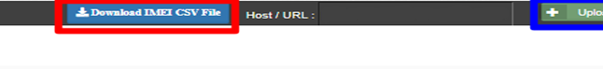
Figure 118 IMEI BULK UPLOAD

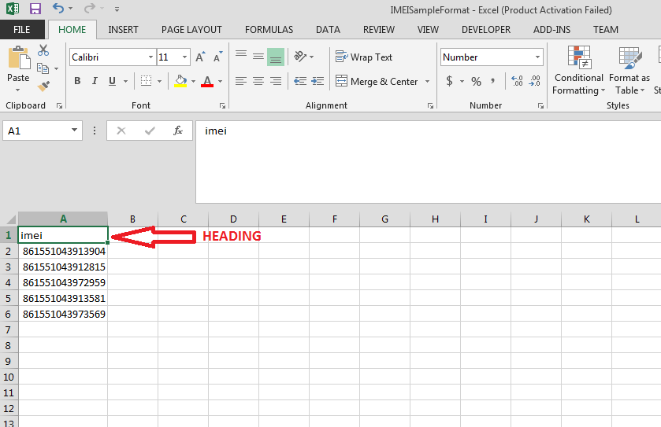

Figure 119 IMEI NO. CSV FORMAT

  - The above image is the CSV file format of IMEI nos.
  - EA user has to keep the heading “imei” as shown in the first row of CSV file and has to enter their own IMEI nos. starting from the 2nd row as shown in the above Figure 128.
  - After creating the CSV file carrying IMEI nos., user has to click on the “Upload Device Registration” button as highlighted in blue in Figure 127: “IMEI bulk upload”.
  - A window screen will appear to upload the CSV file carrying IMEI nos. as shown in below Figure 129.

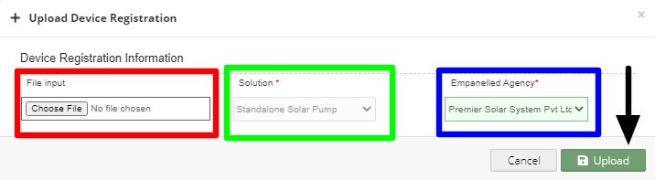
Figure 120 UPLOAD IMEI NO. CSV

  - In above screen, EA user can upload IMEI csv file by clicking on the “Choose File” button. (highlighted in red in above Figure 129)
  - The above screen arrives with the two filters which is by default selected i.e. “Solution” and “Empanelled Agency”
  - EA user can see by default his Empanelled Agency name. (highlighted in blue in above Figure 129)

Registration of single IMEI no.

  - EA user can also register single IMEI no, manually by clicking on the “Add New Device Registration” button from the Device Registration Dashboard. (pointed in below Figure 130)
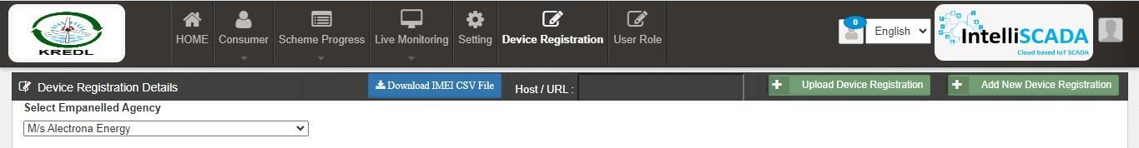
Figure 121 ADD NEW DEVICE REGISTRATION BUTTON

  - When EA user will click on the “Add New Device Registration” button, a window screen will appear to enter the 15 digit IMEI no. (as shown in below Figure 131)
  - When the user select “Is Password” option (highlighted in red in below Figure 131), it will generate the SSL certificates in the Device Registration dashboard, if not selected then it won’t generate the certificates.

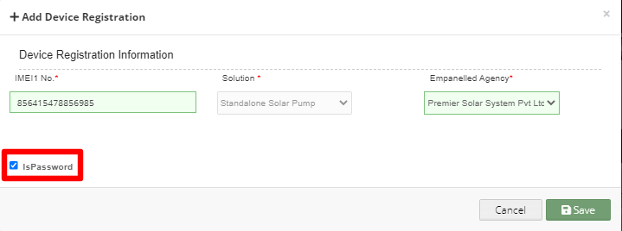
Figure 122 ADD DEVICE REGISTRATION

- After entering IMEI no., user has to click on the save button and IMEI no. will be registered on the portal and is ready to map with necessary consumer/farm18er.
Disclaimer

Nothing in this report constitutes a valuation or legal advice.
- HKRP has not verified the reliability or accuracy of any information obtained in the course of its work, other than in the limited circumstances set out in the Services Contract.

In connection with the report or any part thereof, HKRP does not owe duty of care (whether in contract or in tort or under statute or otherwise) to any person or party to whom the report is circulated to and HKRP shall not be liable to any party who uses or relies on this report. HKRP thus disclaims all responsibility or liability for any costs, damages, losses, liabilities, expenses incurred by such third party arising out of or in connection with the report or any part thereof.

